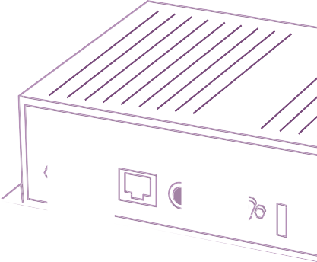

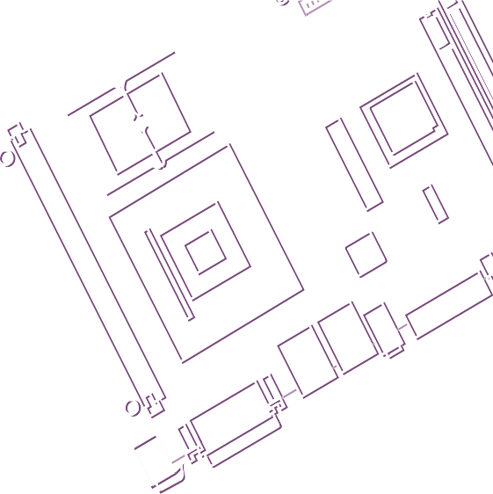
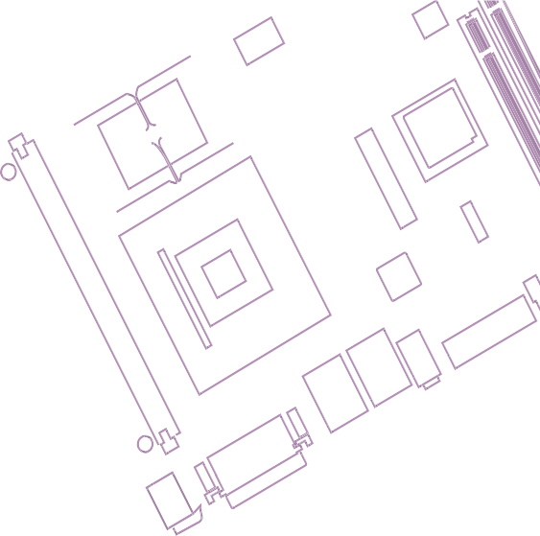
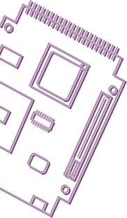





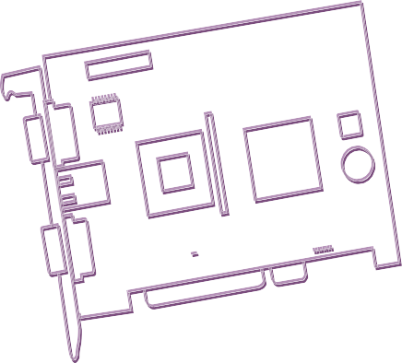


User Manual

AOM-5721

Qualcomm QCS6490 2.7GHz
Gold Plus 8 cores
AOM Nano (SMARC compatible)
The documentation and the software included with this product are copyrighted 2011 by Advantech Co., Ltd. All rights are reserved. Advantech Co., Ltd. reserves the right to make improvements in the products described in this manual at any time without notice. No part of this manual may be reproduced, copied, translated or transmitted in any form or by any means without the prior written permission of Advantech Co., Ltd. Information provided in this manual is intended to be accurate and reliable. However, Advantech Co., Ltd. assumes no responsibility for its use, nor for any infringements of the rights of third parties, which may result from its use.

Acknowledgments
Arm is trademark of Arm Corporation NXP is trademark of NXP Corporation
All other product names or trademarks are properties of their respective owners

Product Warranty (2 years)
Advantech warrants to you, the original purchaser, that each of its products will be free from defects in materials and workmanship for two years from the date of pur- chase.
This warranty does not apply to any products which have been repaired or altered by persons other than repair personnel authorized by Advantech, or which have been subject to misuse, abuse, accident or improper installation. Advantech assumes no liability under the terms of this warranty as a consequence of such events.
Because of Advantech’s high quality-control standards and rigorous testing, most of our customers never need to use our repair service. If an Advantech product is defec- tive, it will be repaired or replaced at no charge during the warranty period. For out- of-warranty repairs, you will be billed according to the cost of replacement materials, service time and freight. Please consult your dealer for more details.
If you think you have a defective product, follow these steps:
- Collect all the information about the problem encountered. (For example, CPU speed, Advantech products used, other hardware and software used, etc.) Note anything abnormal and list any onscreen messages you get when the problem occurs.
- Call your dealer and describe the problem. Please have your manual, product, and any helpful information readily available.
- If your product is diagnosed as defective, obtain an RMA (return merchandize authorization) number from your dealer. This allows us to process your return more quickly.
- Carefully pack the defective product, a fully-completed Repair and Replacement Order Card and a photocopy proof of purchase date (such as your sales receipt) in a shippable container. A product returned without proof of the purchase date is not eligible for warranty service.
- Write the RMA number visibly on the outside of the package and ship it prepaid to your dealer.

Part No. AOM-5721
Printed in China July 2024

FCC Class B
Note: This equipment has been tested and found to comply with the limits for a Class B digital device, pursuant to part 15 of the FCC Rules. These limits are designed to provide reasonable protection against harmful interference in a residential installa- tion. This equipment generates, uses and can radiate radio frequency energy and, if not installed and used in accordance with the instructions, may cause harmful inter- ference to radio communications. However, there is no guarantee that interference will not occur in a particular installation. If this equipment does cause harmful interfer- ence to radio or television reception, which can be determined by turning the equip- ment off and on, the user is encouraged to try to correct the interference by one or more of the following measures:
- Reorient or relocate the receiving antenna.
- Increase the separation between the equipment and receiver.
- Connect the equipment into an outlet on a circuit different from that to which the receiver is connected.
- Consult the dealer or an experienced radio/TV technician for help.

CE

CE compliance was validated at Advantech's system level using an internally designed enclosure. EMC behavior of the bare board is dependent on enclosure design and installation conditions.

Ordering Information

Part No. Description

AOM-5721BO-649AA1 AOM-Nano, QCS6490, -20~70°C, 8 cores

Packing List
Before installation, please ensure the following items have been shipped:
- AOM-5721BO-649AA1

Part No. Description

AOM-DB6700 Carrier board of AOM-5721

96PSA-A60W24T2-3 ADP A/D 100-240V 60W 24V C14 CORD END 2PIN 62368
1700008921 Power Cord 3P PSE 183 cm (72 in)
ROM-EG51 Audio Codec board

9696AEC9100 AOM-EC91 A101 camera evb for AOM-DB6700

1970005260T001 Semi Heat Sink (-20 ~ 70 °C)
1970005259T001 Semi Heat Sink (0 ~ 60 °C)
1970006306N001 Heat Spreader

*
*Please contact us for suggestions on suitable cellular modules for your region.

- Read these safety instructions carefully.
- Keep this User Manual for later reference.
- Disconnect this equipment from any AC outlet before cleaning. Use a damp cloth. Do not use liquid or spray detergents for cleaning.
- For plug-in equipment, the power outlet socket must be located near the equip- ment and must be easily accessible.
- Keep this equipment away from humidity.
- Put this equipment on a reliable surface during installation. Dropping it or letting it fall may cause damage.
- The openings on the enclosure are for air convection. Protect the equipment from overheating. DO NOT COVER THE OPENINGS.
- Make sure the voltage of the power source is correct before connecting the equipment to the power outlet.
- Position the power cord so that people cannot step on it. Do not place anything over the power cord.
- All cautions and warnings on the equipment should be noted.
- If the equipment is not used for a long time, disconnect it from the power source to avoid damage by transient overvoltage.
- Never pour any liquid into an opening. This may cause fire or electrical shock.
- Never open the equipment. For safety reasons, the equipment should be opened only by qualified service personnel.
- If one of the following situations arises, get the equipment checked by service personnel:
  - The power cord or plug is damaged.
  - Liquid has penetrated into the equipment.
  - The equipment has been exposed to moisture.
  - The equipment does not work well, or you cannot get it to work according to the user's manual.
  - The equipment has been dropped and damaged.
  - The equipment has obvious signs of breakage.
DISCLAIMER: This set of instructions is given according to IEC 704-1. Advantech disclaims all responsibility for the accuracy of any statements contained herein.

Safety Precaution - Static Electricity
Follow these simple precautions to protect yourself from harm and the products from damage.
- To avoid electrical shock, always disconnect the power from your PC chassis before you work on it. Don't touch any components on the CPU card or other cards while the PC is on.
- Disconnect power before making any configuration changes. The sudden rush of power as you connect a jumper or install a card may damage sensitive elec- tronic components.

Contents

Chapter 1 General Introduction 1
  - Introduction 2
  - Product Features 2
Table 1.1: Product Features 2
  - Mechanical Specifications 3
    - Electrical Specifications 3
    - Environmental Specifications 3
Chapter 2 H/W Installation 5
  - Board Dimensions 6
  - Block Diagram 6
  - Pin Define 7
Table 2.1: Pin Define 7
  - Quick Start Guide 11
    - Debug Port Connection and Setting 11
Figure 2.1 12
Figure 2.2 12
Figure 2.3 13
Chapter 3 Software Functionality 15
  - Display 16
    - LVDS 16
  - Audio 16
  - M.2 17
    - Test Wi-Fi with EWM-W194M201E Module (SDIO Interface) 17
    - Test Bluetooth with EWM-W194M201E Module (UART Interface). 17
  - Serial Port (COM A/C) 18
    - RS-232 Loopback Test (eg. ttyLP0) 18
    - RS-422 Test 18
    - RS-485 Test 18
  - I2C 18
  - USB 19
  - RTC 19
  - eMMC/SD 19
    - Device Routes 19
  - Ethernet 20
  - GPIO 20
    - GPIO Pins 20
Table 3.1: GPIO Pins 20
    - GPIO Loopback Test (Using GPIO1 and GPIO2 as examples) 21
  - Camera 21
    - MIPI-CSI0 (Tested with OV5640 + mini-SAS to MIPI-CSI Cable) .. 21
  - PWM 21
  - M33 Function 22
    - CAN Bus 23
    - QSPI 23
    - LPSPI 24
    - LPUART 24
Chapter 4 Embedded OS 27
  - Introduction 28
    - Device Tree Source File Select for AOM-5721 28
    - Module 28
Chapter 5 System Recovery 29
  - System Recovery 30
    - Recovery by UUU Tool 30
Chapter 6 Advantech Services 31
  - RISC Design-In Services 32
  - Contact Information 35
  - Technical Support and Assistance 36
    - Warranty Policy 36
    - Repair Process 37

Chapter 1

General Introduction
This chapter details background information on the AOM-5721.
Sections include:
- Introduction
- Specifications

Introduction
Advantech's AOM-5721 is powered by Qualcomm QCS6490 SoC which includes up
to Kryo 8 cores up to 2.7GHz in combination with Adreno GPU 643 and Adreno VPU
633 graphics engine. It provides PCIe, USB 3.2, Giga Ethernet, MIPI-CSI, I2C,SPI,
GPIO,
and HDMI, DP, 2ch. LVDS display for embedded applications.
AOM-5721 is paired with Advantech OSM carrier board for faster end product
peripheral integration and time-to-market. The reference schematics and layout
checklists documentations for carrier board development will be provided along with
Windows 11, Ubuntu, test utilities, hardware design utilities and reference drivers.

Product Features
Table 1.1: Product Features
Model Name AOM-5721

Form Factor AOM Nano

Processor System

Memory

Graphics
CPU QCS6490 Kryo 8 Cores up to 2.7GHz

Technology Up to 6400MT/s

Capacity Up to 16GB LPDDR5 (On-board)

Flash 128 GB eMMC or 128GB UFS for O.S.
HDMI 1 x HDMI 1920x1080 @60Hz (Share 2.ch LVDS port)
LVDS 1 x Dual channel LVDS1920x1080 @60Hz (Share HDMI port)
DP 1x DP 2lane: 1920x1080 @60Hz

Adreno VPU 633 4K30 encode/Decode
Graphics Engine Adreno GPU 643, OpenGL ES3.2/OpenCL 2.0

Ethernet Chipset 1 x QPS615 integrated RGMII and SGMII
 | Speed | 2 x 10/100/1000 Mbps
RTC | RTC | External RTC
Security |  | Qualcomm® Trusted Execution Environment (TEE) v5.3
 | USB | 1 x USB3.2 Gen 1 and 1 x USB2.0
 | Audio | 1 x I2S

I/O
Serial Port 2 x 4-wire UART, 2 x 2-wire UART,
1 x 2-wire UART for debug console
SPI 2
CAN-FD 2
GPIO 14
SDIO 1
I2C 5(I2C_GP,I2C_LCD,I2C_PM,I2C_CAM1,I2C_CAM0)
Camera Input 1 x MIPI CSI 4-lane, 1 x MIPI CSI 2-lane (SMARC Edge Connector), 2 x MIPI CSI 4-lane (Connector)
Power Supply Voltage 5V
Power Power Consumption TBD
Environment
Operational Temperature
-20 ~ 70 °C

Operating Humidity 5 ~ 95% Relative Humidity, non-condensing Mechanical Dimensions (W x D) 82 x 50 mm
Operating System Yocto Linux, Ubuntu Linux, Windows 11 IoT, Android
Certifications CE/FCC Class B

Chapter 1
General Introduction

Mechanical Specifications
- Dimensions: 82 x 50 mm

Electrical Specifications

Power Supply: 5V

Environmental Specifications
      - Operating Temperature: -20 ~ 70 °C
      - Operating Humidity: 95% @ 40°C (non-condensing)
      - Storage Temperature: -40° to 85°C
      - Storage Humidity: 95% @ 60°C (non-condensing)

3 AOM-5721 User Manual

Chapter 2

H/W Installation
This chapter details mechanical and connector information.
Sections include:
- Mechanical Drawing
- Pin Define
- Quick Start Guide

AOM-5721 Board Dimensions
• •
• •

Block Diagram
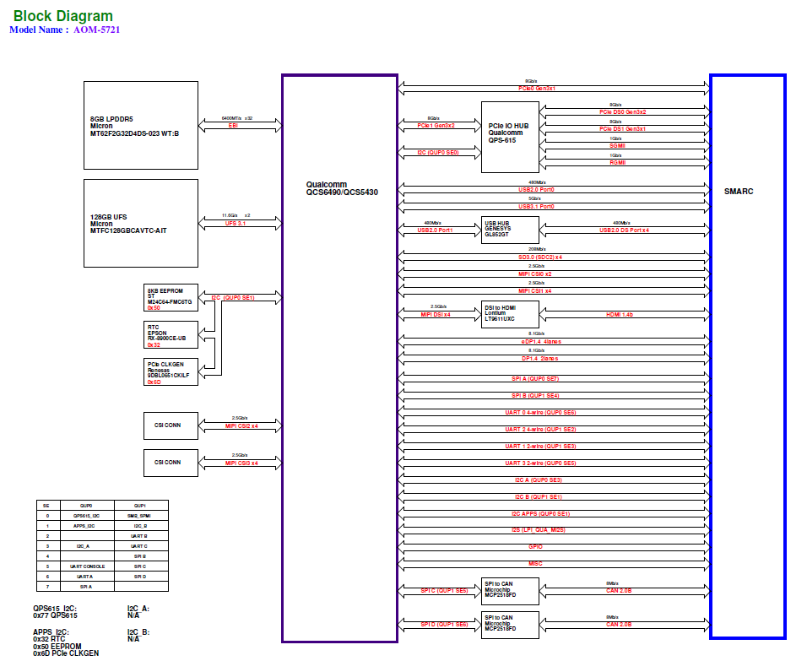

Pin Define

P-Pin | Primary (Top) Side | I/F | AOM-5721 SMARC Schematic Checklist V2.2-Internal
P1 | SMB_ALERT# | SMB | N/A
P2 | GND | POWER | GND
P3 | CSI1_CK+ | SCAM | CSI1_CLK+
P4 | CSI1_CK- | SCAM | CSI1_CLK-
P5 | GBE1_SDP | GBE | N/A
P6 | GBE0_SDP | GBE | N/A
P7 | CSI1_RX0+ | SCAM | CSI1_D0+
P8 | CSI1_RX0- | SCAM | CSI1_D0-
P9 | GND | POWER | GND
P10 | CSI1_RX1+ | SCAM | CSI1_D1+
P11 | CSI1_RX1- | SCAM | CSI1_D1-
P12 | GND | POWER | GND
P13 | CSI1_RX2+ | SCAM | CSI1_D2+
P14 | CSI1_RX2- | SCAM | CSI1_D2-
P15 | GND | POWER | GND
P16 | CSI1_RX3+ | SCAM | CSI1_D3+
P17 | CSI1_RX3- | SCAM | CSI1_D3-
P18 | GND | POWER | GND
P19 | GBE0_MDI3- | GBE | GBE0_MDI3-
P20 | GBE0_MDI3+ | GBE | GBE0_MDI3+
P21 | GBE0_LINK_MID# | GBE | GBE0_LED_100#
P22 | GBE0_LINK_MAX# | GBE | GBE0_LED_1000#
P23 | GBE0_MDI2- | GBE | GBE0_MDI2-
P24 | GBE0_MDI2+ | GBE | GBE0_MDI2+
P25 | GBE0_LINK_ACT# | GBE | GBE0_LED_ACT#
P26 | GBE0_MDI1- | GBE | GBE0_MDI1-
P27 | GBE0_MDI1+ | GBE | GBE0_MDI1+
P28 | GBE0_CTREF | GBE | N/A
P29 | GBE_MDI0- | GBE | GBE0_MDI0-
P30 | GBE_MDI0+ | GBE | GBE0_MDI0+
P31 | SPI0_CS1# | SPI | SPI0_CS3#
P32 | GND | POWER | GND
P33 | SDIO_WP | SDIO | SD_WRITE_PROTECT
P34 | SDIO_CMD | SDIO | SDC2_CMD
P35 | SDIO_CD# | SDIO | SD_CARD_DET#
P36 | SDIO_CK | SDIO | SDC2_CLK
P37 | SDIO_PWR_EN | SDIO | SDC2_PWR_EN
P38 | GND | POWER | GND
P39 | SDIO_D0 | SDIO | SDC2_DATA_0
P40 | SDIO_D1 | SDIO | SDC2_DATA_1
P41 | SDIO_D2 | SDIO | SDC2_DATA_2
P42 | SDIO_D3 | SDIO | SDC2_DATA_3

P-Pin | Primary (Top) Side | I/F | AOM-5721 SMARC Schematic Checklist V2.2-Internal
P43 | SPI0_CS0# | SPI | SPI0_CS0#
P44 | SPI0_CK | SPI | SPI0_SCLK
P45 | SPI0_DIN | SPI | SPI0_MISO
P46 | SPI0_DO | SPI | SPI0_MOSI
P47 | GND | POWER | GND
P48 | SATA_TX+ | SATA | N/A
P49 | SATA_TX- | SATA | N/A
P50 | GND | POWER | GND
P51 | SATA_RX+ | SATA | N/A
P52 | SATA_RX- | SATA | N/A
P53 | GND | POWER | GND
P54 | ESPI_CS0# / SPI1_CS0# / QSPI_CS0# | SPI | SPI1_CS0#
P55 | ESPI_CS1# / SPI1_CS1# / QSPI_CS1# | SPI | SPI1_CS3#
P56 | ESPI_CK / SPI1_CK / QSPI_CK | SPI | SPI1_SCLK
P57 | ESPI_IO_1 / ESPI_IO_1 / QSPI_IO_1 | SPI | SPI1_MISO
P58 | ESPI_IO_0 / SPI1_DO /  QSPI_IO_0 | SPI | SPI1_MOSI
P59 | GND | POWER | GND
P60 | USB0+ | USB | USB0_HS_D+
P61 | USB0- | USB | USB0_HS_D-
P62 | USB0_EN_OC# | USB | USB0_OC#_GF
P63 | USB0_VBUS_DET | USB | USB0_VBUS_DET
P64 | USB0_OTG_ID | USB | USB0_ID_GF
P65 | USB1+ | USB | USB1+
P66 | USB1- | USB | USB1-
P67 | USB1_EN_OC# | USB | USB1_OC#_GF
P68 | GND | POWER | GND
P69 | USB2+ | USB | USB2+
P70 | USB2- | USB | USB2-
P71 | USB2_EN_OC# | USB | USB2_OC#_GF
P72 | RSVD | RSVD | USB3+
P73 | RSVD | RSVD | USB3-
P74 | USB3_EN_OC# | USB | USB3_OC#_GF
<Key>
P75 | PCIE_A_RST# | PCIe | PCIe_A_RST#
P76 | USB4_EN_OC# | USB | USB4_OC#_GF
P77 | PCIE_B_CKREQ# | PCIe | PCIe_B_CLKREQ#
P78 | PCIE_A_CKREQ# | PCIe | PCIe_A_CLKREQ#
P79 | GND | POWER | GND
P80 | PCIE_C_REFCK+ | PCIe | QPS_DS0_PCIE0_REFCLK+
P81 | PCIE_C_REFCK- | PCIe | QPS_DS0_PCIE0_REFCLK-
P82 | GND | POWER | GND
P83 | PCIE_A_REFCK+ | PCIe | PCIE0_REFCLK+
P84 | PCIE_A_REFCK- | PCIe | PCIE0_REFCLK-
P85 | GND | POWER | GND

P-Pin | Primary (Top) Side | I/F | AOM-5721 SMARC Schematic Checklist V2.2-Internal
P86 | PCIE_A_RX+ | PCIe | PCIE0_RX+
P87 | PCIE_A_RX- | PCIe | PCIE0_RX-
P88 | GND | POWER | GND
P89 | PCIE_A_TX+ | PCIe | PCIE0_TX+
P90 | PCIE_A_TX- | PCIe | PCIE0_TX-
P91 | GND | POWER | GND
P92 | HDMI_D2+ / DP1_LANE0+ | HDMI/DP | HDMI_D2+
P93 | HDMI_D2- / DP1_LANE0- | HDMI/DP | HDMI_D2-
P94 | GND | POWER | GND
P95 | HDMI_D1+ / DP1_LANE1+ | HDMI/DP | HDMI_D1+
P96 | HDMI_D1- / DP1_LANE1- | HDMI/DP | HDMI_D1-
P97 | GND | POWER | GND
P98 | HDMI_D0+ / DP1_LANE2+ | HDMI/DP | HDMI_D0+
P99 | HDMI_D0- / DP1_LANE2- | HDMI/DP | HDMI_D0-
P100 | GND | POWER | GND
P101 | HDMI_CK+ / DP1_LANE3+ | HDMI/DP | HDMI_CK+
P102 | HDMI_CK- / DP1_LANE3- | HDMI/DP | HDMI_CK-
P103 | GND | POWER | GND
P104 | HDMI_HPD / DP1_HPD | HDMI/DP | HDMI_HPD
P105 | HDMI_CTRL_CK / DP1_AUX+ | HDMI/DP | DDC_CLK_HDMI
P106 | HDMI_CTRL_DAT / DP1_AUX+ | HDMI/DP | DDC_DATA_HDMI
P107 | DP1_AUX_SEL | DP | N/A
P108 | GPIO0 / CAM0_PWR# | GPIO/SCAM | CAM0_PWDN
P109 | GPIO1 / CAM1_PWR# | GPIO/SCAM | CAM1_PWDN
P110 | GPIO2 / CAM0_RST# | GPIO/SCAM | CAM0_RESET#
P111 | GPIO3 / CAM1_RST# | GPIO/SCAM | CAM1_RESET#
P112 | GPIO4 / HDA_RST# | GPIO/HDA | QCS_GPIO_8
P113 | GPIO5 / PWM_OUT | GPIO/FAN | QCS_GPIO_11
P114 | GPIO6 / TACHIN | GPIO/FAN | QCS_GPIO_15
P115 | GPIO7 | GPIO | QCS_GPIO_16
P116 | GPIO8 | GPIO | QCS_GPIO_18
P117 | GPIO9 | GPIO | QCS_GPIO_19
P118 | GPIO10 | GPIO | QCS_GPIO_35
P119 | GPIO11 | GPIO | QCS_GPIO_44
P120 | GND | POWER | GND
P121 | I2C_PM_CK | PSM | APPS_I2C_SCL
P122 | I2C_PM_DAT | PSM | APPS_I2C_SDA
P123 | BOOT_SEL0# | MISC | QCS_GPIO_113
P124 | BOOT_SEL1# | MISC | QCS_GPIO_114
P125 | BOOT_SEL2# | MISC | QCS_GPIO_115
P126 | RESET_OUT# | PSM | QCM_RESOUT#
P127 | RESET_IN# | PSM | PM_RESIN#
P128 | POWER_BTN# | PSM | PHONE_ON#

P-Pin | Primary (Top) Side | I/F | AOM-5721 SMARC Schematic Checklist V2.2-Internal
P129 | SER0_TX | SER | UART_A_TX
P130 | SER0_RX | SER | UART_A_RX
P131 | SER0_RTS# | SER | UART_A_RTS#
P132 | SER0_CTS# | SER | UART_A_CTS#
P133 | GND |  | GND
P134 | SER1_TX | SER | UART_C_TX
P135 | SER1_RX | SER | UART_C_RX
P136 | SER2_TX | SER | UART_B_TX
P137 | SER2_RX | SER | UART_B_RX
P138 | SER2_RTS# | SER | UART_B_RTS#
P139 | SER2_CTS# | SER | UART_B_CTS#
P140 | SER3_TX | SER | UART_CON_TX
P141 | SER3_RX | SER | UART_CON_RX
P142 | GND | POWER | GND
P143 | CAN0_TX | CAN | CAN0_TX
P144 | CAN0_RX | CAN | CAN0_RX
P145 | CAN1_TX | CAN | CAN1_TX
P146 | CAN1_RX | CAN | CAN1_RX
P147 | VDD_IN | POWER | VDD_IN
P148 | VDD_IN | POWER | VDD_IN
P149 | VDD_IN | POWER | VDD_IN
P150 | VDD_IN | POWER | VDD_IN
P151 | VDD_IN | POWER | VDD_IN
P152 | VDD_IN | POWER | VDD_IN
P153 | VDD_IN | POWER | VDD_IN
P154 | VDD_IN | POWER | VDD_IN
P155 | VDD_IN | POWER | VDD_IN
P156 | VDD_IN | POWER | VDD_IN

S-Pin | Secondary (Bottom) Side | I/F | AOM-5721 SMARC Schematic Checklist V2.2-Internal
S1 | CSI1_TX+ / I2C_CAM1_CK | SCAM | CCI_I2C1_SCL
S2 | CSI1_TX- / I2C_CAM1_DAT | SCAM | CCI_I2C1_SDA
S3 | GND | POWER | GND
S4 | RSVD | RSVD | CAM_MCLK1
S5 | CSI0_TX+ / I2C_CAM0_CK | SCAM | CCI_I2C0_SCL
S6 | CAM_MCK | SCAM | CAM_MCLK0
S7 | CSI0_TX- / I2C_CAM0_DAT | SCAM | CCI_I2C0_SDA
S8 | CSI0_CK+ | SCAM | CSI0_CLK+
S9 | CSI0_CK- | SCAM | CSI0_CLK-
S10 | GND | POWER | GND
S11 | CSI0_D0+ | SCAM | CSI0_D0+
S12 | CSI0_D0- | SCAM | CSI0_D0-
S13 | GND | POWER | GND
S14 | CSI0_D1+ | SCAM | CSI0_D1+
S15 | CSI0_D1- | SCAM | CSI0_D1-
S16 | GND | POWER | GND
S17 | GBE1_MDI0+ | GBE | GBE1_MDI0+
S18 | GBE1_MDI0- | GBE | GBE1_MDI0-
S19 | GBE1_LINK_MID# | GBE | GBE1_LED_100#
S20 | GBE1_MDI1+ | GBE | GBE1_MDI1+
S21 | GBE1_MDI1- | GBE | GBE1_MDI1-
S22 | GBE1_LINK_MAX# | GBE | GBE1_LED_1000#
S23 | GBE1_MDI2+ | GBE | GBE1_MDI2+
S24 | GBE1_MDI2- | GBE | GBE1_MDI2-
S25 | GND | POWER | GND
S26 | GBE1_MDI3+ | GBE | GBE1_MDI3+
S27 | GBE1_MDI3- | GBE | GBE1_MDI3-
S28 | GBE1_CTREF | GBE | N/A
S29 | PCIE_D_TX+ / SERDES_0_TX+ | GBE | QPS_DS0_PCIE0_TX1+
S30 | PCIE_D_TX- / SERDES_0_TX- | GBE | QPS_DS0_PCIE0_TX1-
S31 | GBE1_LINK_ACT# | GBE | GBE1_LED_ACT#
S32 | PCIE_D_RX+ / SERDES_0_RX+ | PCIe | QPS_DS0_PCIE0_RX1+
S33 | PCIE_D_RX- / SERDES_0_RX- | PCIe | QPS_DS0_PCIE0_RX1-
S34 | GND | POWER | GND
S35 | USB4+ | USB | USB4+
S36 | USB4- | USB | USB4-
S37 | USB3_VBUS_DET | USB | N/A
S38 | AUDIO_MCK | I2S | I2S_MCLK
S39 | I2S0_LRCK | I2S | LPI_I2S2_WS
S40 | I2S0_SDOUT | I2S | LPI_I2S2_DATA1
S41 | I2S0_SDIN | I2S | LPI_I2S2_DATA0
S42 | I2S0_CK | I2S | LPI_I2S2_CLK
S43 | ESPI_ALERT0# | SPI | N/A
S44 | ESPI_ALERT1# | SPI | N/A
S-Pin | Secondary (Bottom) Side | I/F | AOM-5721 SMARC Schematic Checklist V2.2-Internal
S45 | MDIO_CLK | MDIO | N/A
S46 | MDIO_DAT | MDIO | N/A
S47 | GND | POWER | GND
S48 | I2C_GP_CK | I2C | I2C_A_SCL
S49 | I2C_GP_DAT | I2C | I2C_A_SDA
S50 | HDA_SYNC / I2S2_LRCK / SNDW_CLK1 | I2S | SWR_TX_CLK
S51 | HDA_SDO / I2S2_SDOUT / SNDW_DAT1 | I2S | SWR_TX_DATA0
S52 | HDA_SDI / I2S2_SDIN / SNDW_DAT0 | I2S | SWR_RX_DATA0
S53 | HDA_CK / I2S2_CK / SNDW_CLK0 | I2S | SWR_RX_CLK
S54 | SATA_ACT# | SATA | N/A
S55 | USB5_EN_OC# | USB | N/A
S56 | ESPI_IO_2 / QSPI_IO_2 | SPI | N/A
S57 | ESPI_IO_3 / QSPI_IO_3 | SPI | N/A
S58 | ESPI_RESET# | SPI | N/A
S59 | USB5+ | USB | N/A
S60 | USB5- | USB | N/A
S61 | GND | POWER | GND
S62 | USB3_SSTX+ | USB | N/A
S63 | USB3_SSTX- | USB | N/A
S64 | GND | POWER | GND
S65 | USB3_SSRX+ | USB | N/A
S66 | USB3_SSRX- | USB | N/A
S67 | GND | POWER | GND
S68 | USB3+ | USB | USB3+
S69 | USB3- | USB | USB3-
S70 | GND | POWER | GND
S71 | USB2_SSTX+ | USB | USB0_SS_TX1+
S72 | USB2_SSTX- | USB | USB0_SS_TX1-
S73 | GND | POWER | GND
S74 | USB2_SSRX+ | USB | USB0_SS_RX1+
S75 | USB2_SSRX- | USB | USB0_SS_RX1-
<Key>
S76 | PCIE_B_RST# | PCIe | PCIe_B_RST#
S77 | PCIE_C_RST# / SERDES_RST# | PCIe | PCIe_C_RST#
S78 | PCIE_C_RX+ / SERDES_1_RX+ | PCIe | QPS_DS0_PCIE0_RX0+
S79 | PCIE_C_RX- / SERDES_1_RX- | PCIe | QPS_DS0_PCIE0_RX0-
S80 | GND | POWER | GND
S81 | PCIE_C_TX+ / SERDES_1_TX+ | PCIe | QPS_DS0_PCIE0_TX0+
S82 | PCIE_C_TX- / SERDES_1_TX- | PCIe | QPS_DS0_PCIE0_TX0-
S83 | GND | POWER | GND
S84 | PCIE_B_REFCK+ | PCIe | QPS_DS1_PCIE1_REFCLK+
S85 | PCIE_B_REFCK- | PCIe | QPS_DS1_PCIE1_REFCLK-
S86 | GND | POWER | GND
S87 | PCIE_B_RX+ | PCIe | QPS_DS1_PCIE1_RX0+
S88 | PCIE_B_RX- | PCIe | QPS_DS1_PCIE1_RX0-
  - Table 0.1 AOM-5721 Secondary (Bottom) Side Pin-out

S-Pin | Secondary (Bottom) Side | I/F | AOM-5721 SMARC Schematic Checklist V2.2-Internal
S89 | GND | POWER | GND
S90 | PCIE_B_TX+ | PCIe | QPS_DS1_PCIE1_TX0+
S91 | PCIE_B_TX- | PCIe | QPS_DS1_PCIE1_TX0-
S92 | GND | POWER | GND
S93 | DP0_LANE0+ | DP | USB0_SS_RX0+
S94 | DP0_LANE0- | DP | USB0_SS_RX0-
S95 | DP0_AUX_SEL | DP | N/A
S96 | DP0_LANE1+ | DP | USB0_SS_TX0+
S97 | DP0_LANE1- | DP | USB0_SS_TX0-
S98 | DP0_HPD | DP | DP_HOT_PLUG_DETECT
S99 | DP0_LANE2+ | DP | N/A
S100 | DP0_LANE2- | DP | N/A
S101 | GND | POWER | GND
S102 | DP0_LANE3+ | DP | N/A
S103 | DP0_LANE3- | DP | N/A
S104 | USB3_OTG_ID | USB | N/A
S105 | DP0_AUX+ | DP | USB0_DP_AUX_CONN+
S106 | DP0_AUX- | DP | USB0_DP_AUX_CONN-
S107 | LCD1_BKLT_EN | LVDS | QCS_GPIO_110
S108 | LVDS1_CK+ / EDP1_AUX+ / DSI1_CLK+ | LVDS/eDP/DSI | DSI_GF_CLK+
S109 | LVDS1_CK- / EDP1_AUX- / DSI1_CLK- | LVDS/eDP/DSI | DSI_GF_CLK-
S110 | GND | POWER | GND
S111 | LVDS1_0+ / EDP1_TX0+ / DSI1_D0+ | LVDS/eDP/DSI | DSI_GF_D0+
S112 | LVDS1_0- / EDP1_TX0- / DSI1_D0- | LVDS/eDP/DSI | DSI_GF_D0-
S113 | eDP1_HPD / DSI1_TE | eDP/DSI | DSI0_TE
S114 | LVDS1_1+ / EDP1_TX1+ / DSI1_D+ | LVDS/eDP/DSI | DSI_GF_D1+
S115 | LVDS1_1- / EDP1_TX1- / DSI1_D1- | LVDS/eDP/DSI | DSI_GF_D1-
S116 | LCD1_VDD_EN | LCD | QCS_GPIO_109
S117 | LVDS1_2+ / EDP1_TX2+ / DSI1_D2+ | LVDS/eDP/DSI | DSI_GF_D2+
S118 | LVDS1_2- / EDP1_TX2- / DSI1_D2- | LVDS/eDP/DSI | DSI_GF_D2-
S119 | GND | POWER | GND
S120 | LVDS1_3+ / EDP1_TX3+ / DSI1_D3+ | LVDS/eDP/DSI | DSI_GF_D3+
S121 | LVDS1_3- / EDP1_TX3- / DSI1_D3- | LVDS/eDP/DSI | DSI_GF_D3-
S122 | LCD1_BKLT_PWM | LCD | N/A
S123 | GPIO13 | GPIO | QCS_GPIO_104

S-Pin | Secondary (Bottom) Side | I/F | AOM-5721 SMARC Schematic Checklist V2.2-Internal
S124 | GND | POWER | GND
S125 | LVDS0_0+ / EDP0_TX0+ / DSI0_D0+ | LVDS/eDP/DSI | EDP0_TX0_FLT+
S126 | LVDS0_0- / EDP0_TX0- / DSI0_D0- | LVDS/eDP/DSI | EDP0_TX0_FLT-
S127 | LCD0_BKLT_EN | LCD | PMC_GPIO_07_CONN_EDP_BL_EN
S128 | LVDS0_1+ / EDP0_TX1+ / DSI0_D1+ | LVDS/eDP/DSI | EDP0_TX1_FLT+
S129 | LVDS0_1- / EDP0_TX1- / DSI0_D1- | LVDS/eDP/DSI | EDP0_TX1_FLT-
S130 | GND | POWER | GND
S131 | LVDS0_2+ / EDP0_TX2+ / DSI0_D2+ | LVDS/eDP/DSI | EDP0_TX2_FLT+
S132 | LVDS0_2- / EDP0_TX2- / DSI0_D2- | LVDS/eDP/DSI | EDP0_TX2_FLT-
S133 | LCD0_VDD_EN | LCD | QCS_GPIO_80
S134 | LVDS0_CK+ / EDP0_AUX+ / DSI0_CLK+ | LVDS/eDP/DSI | EDP0_AUX_CONN+
S135 | LVDS0_CK- / EDP0_AUX- / DSI0_CLK- | LVDS/eDP/DSI | EDP0_AUX_CONN-
S136 | GND | POWER | GND
S137 | LVDS0_3+ / EDP0_TX3+ / DSI0_D3+ | LVDS/eDP/DSI | EDP0_TX3_FLT+
S138 | LVDS0_3- / EDP0_TX3- / DSI0_D3- | LVDS/eDP/DSI | EDP0_TX3_FLT-
S139 | I2C_LCD_CK | LCD | I2C_B_SCL
S140 | I2C_LCD_DAT | LCD | I2C_B_SDA
S141 | LCD0_BKLT_PWM | LCD | PMC_GPIO_08_CONN_EDP_PWM
S142 | GPIO12 | GPIO | QCS_GPIO_68
S143 | GND | POWER | GND
S144 | eDP0_HPD / DSI0_TE | eDP/DSI | EDP_HOT_PLUG_DETECT
S145 | WDT_TIME_OUT# | WDT | QCS_GPIO_17
S146 | PCIE_WAKE# | PCIe | PCIE_WAKE#
S147 | VDD_RTC | POWER | +RTC_PWR
S148 | LID# | PSM | QCS_GPIO_112
S149 | SLEEP# | PSM | QCS_GPIO_116
S150 | VIN_PWR_BAD# | PSM | VIN_PWR_BAD#
S151 | CHARGING# | PSM | PCIe_C_CLKREQ#
S152 | CHARGER_PRSNT# | PSM | QCS_GPIO_9
S153 | CARRIER_STBY# | PSM | QCS_GPIO_10
S154 | CARRIER_PWR_ON | PSM | CARRIER_PWR_EN
S155 | FORCE_RECOV# | MISC | FORCE_RECOV#
S156 | BATLOW# | PSM | QCS_GPIO_111
S157 | TEST# | PSM | KYPD_VOL_UP#
S158 | GND | POWER | GND

Quick Start Guide

I/O Description of AOM-DB6700
AOM-DB6700 is an evaluation board for AOM-5721. Please see the I/O description of AOM-DB6700 below.

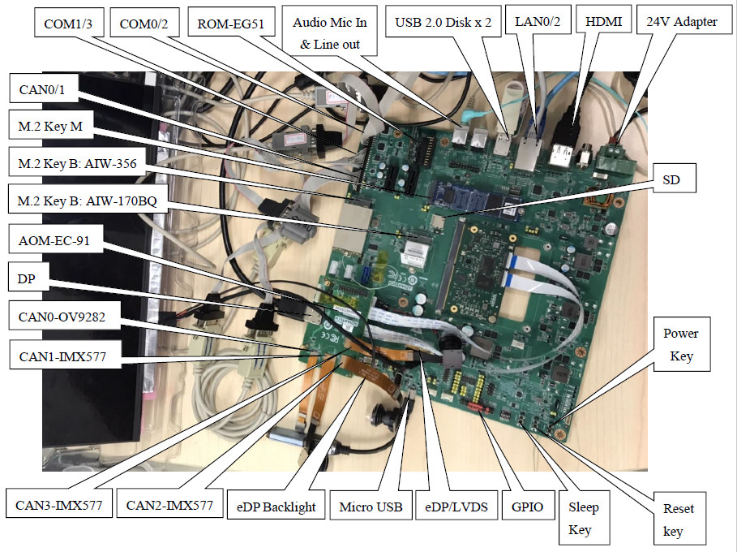

Switch Setting for AOM-DB6700

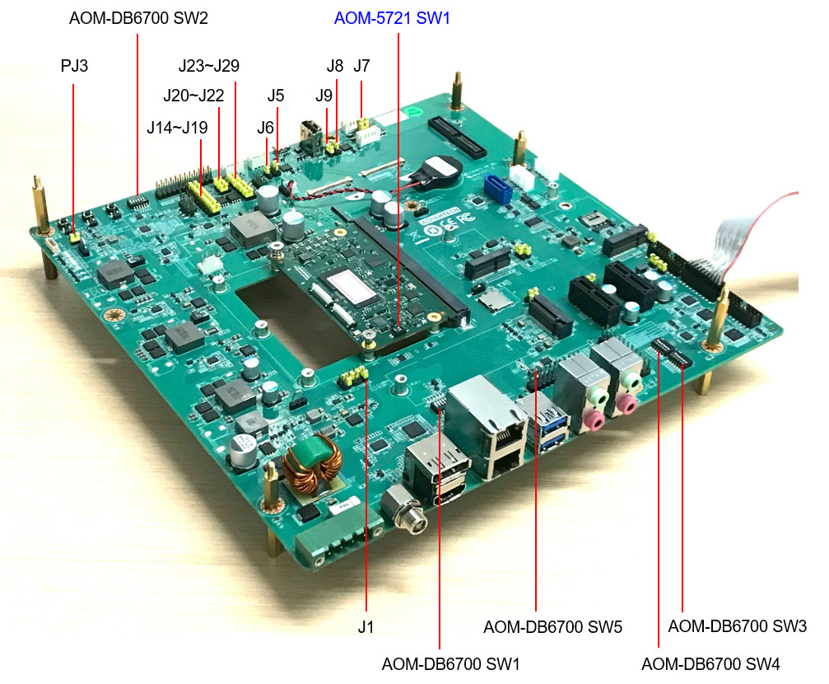

AOM-DB6700 SW1 (LAN LED HW Setting)

SW1 set to default 1-on, 2-on, 3-on, 4-on, 5-off, 6-off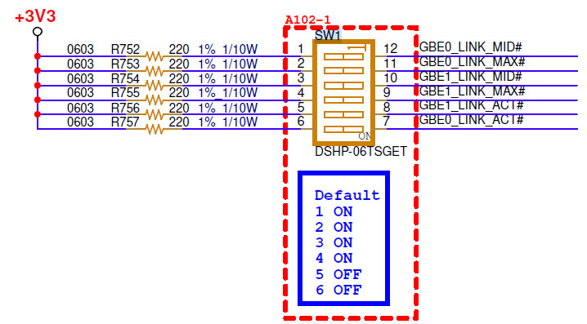

AOM-DB6700 SW2 (BOOT Selection)

Normal Boot: SW2 set to default 1-on, 2-off, 3-off, 4-off, 5-off, 6-off

Force Recovery (QDL Download): SW2 set to 1-on, 2-off, 3-off, 4-on, 5-off, 6-off

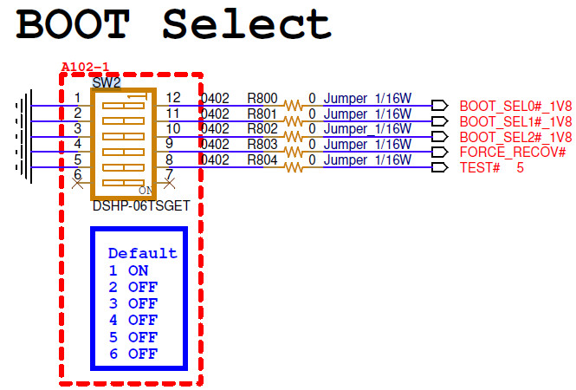

AOM-DB6700 SW3 (COM0 HW Setting)

RS232 Loopback Mode: SW3 set to 1-off, 2-off, 3-off, 4-off, 5-off, 6-off

RS232 Mode: SW3 set to default 1-on, 2-off, 3-off, 4-off, 5-off, 6-off

RS485 Half-Duplex Mode: SW3 set to 1-off, 2-on, 3-off, 4-on, 5-on, 6-off

RS485 Full-Duplex (RS422) Mode: SW3 set to 1-on, 2-on, 3-off, 4-on, 5-on, 6-off

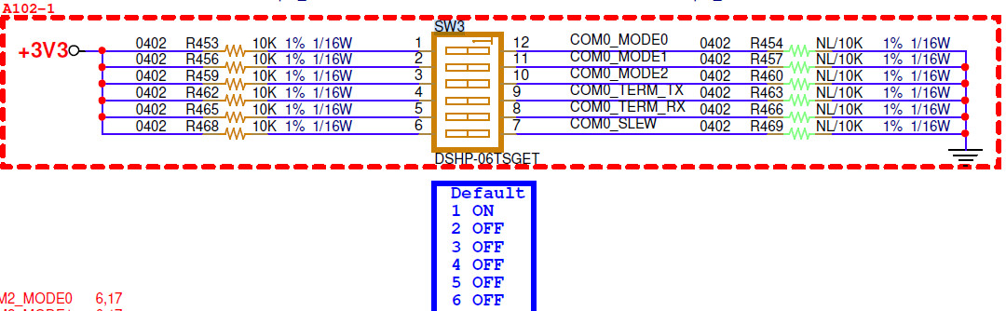

AOM-DB6700 SW4 (COM2 HW Setting)

RS232 Loopback Mode: SW4 set to 1-off, 2-off, 3-off, 4-off, 5-off, 6-off

RS232 Mode: SW4 set to default 1-on, 2-off, 3-off, 4-off, 5-off, 6-off

RS485 Half-Duplex Mode: SW4 set to 1-off, 2-on, 3-off, 4-on, 5-on, 6-off

RS485 Full-Duplex (RS422) Mode: SW4 set to 1-on, 2-on, 3-off, 4-on, 5-on, 6-off

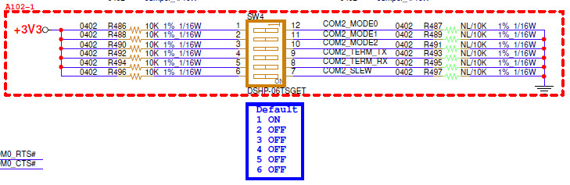

AOM-DB6700 SW5 (I2S2 MCK Selection)

CPU MCLK: SW5 set to 1 (Use the default)

OSC MCLK: SW5 set to 2

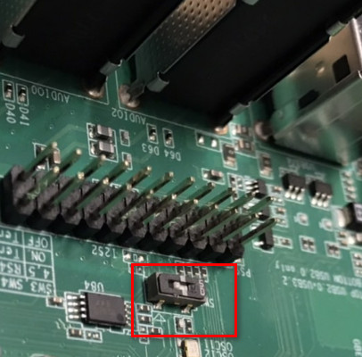

AOM-DB6700 PJ3 (ATX Mode Or AT Mode Selection)

ATX Mode: Jumper set to (1-2)

AT Mode (Default): Jumper set to (2-3)

AOM-DB6700 J1 (Carrier HDMI0 Or DP1 Selection)

HDMI0 (Default): Jumper set to (1-2)

DP1: Jumper set to (2-3)

AOM-DB6700 J5 (LVDS0 PWR Selection)

+5V: Jumper set to (1-3)

+12V: Jumper set to (3-4)

+3V3 (Default): Jumper set to (3-5)

AOM-DB6700 J6 (LVDS0/EDP0 HPD Selection)

LVDS: Jumper set to (1-2)

EDP_HPD (Default): Jumper set to (2-3)

AOM-DB6700 J7 (LVDS0 Backlight PWR Selection)

+5V: Jumper set to (1-2)

+12V: Jumper set to (2-3)

AOM-DB6700 J8 (LVDS1 PWR Selection)

+5V: Jumper set to (1-3)

+12V: Jumper set to (3-4)

+3V3 (Default): Jumper set to (3-5)

AOM-DB6700 J9 (LVDS1/EDP1 HPD Selection)

LVDS (Default): Jumper set to (1-2)

EDP_HPD: Jumper set to (2-3)

AOM-DB6700 J14 (SPI0 CS Selection)

CS0 (Default): Jumper set to (1-2)

CS1: Jumper set to (2-3)

AOM-DB6700 J15~J19 (SPI0 Flash Selection)

Flash (Default): Jumper set to (1-2)

PIN HEADER: Jumper set to (2-3)

AOM-DB6700 J20 (ESPI/SPI1/QSPI CS Selection)

CS0 (Default): Jumper set to (1-2)

CS1: Jumper set to (2-3)

AOM-DB6700 J21,J22 (SPI1/QSPI Selection)

SPI1 (Default): Jumper set to (1-2)

QSPI: Jumper set to (2-3)

AOM-DB6700 J23~J29 (SPI1/ESPI Flash Selection)

Flash (Default): Jumper set to (1-2)

PIN HEADER: Jumper set to (2-3)

UART Debug Console
Follow these steps to connect the device to the host machine through UART.

Use the serial COM tool, such as PuTTY or Tera Term and set "Speed" to 115200
Connect the debug cable to the "COM3" and connect the device to the host machine
Connect the 24V power adapter to "24V DC-IN"
Push the "Power Button" to power on the device for the ATX mode
View the serial log dump on your console
Log in with account and password
Account: root
Password: oelinux123

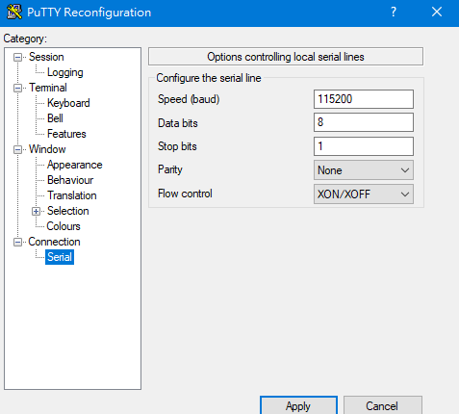

Note! The debug cable needs to be purchased separately.


Part Number | Description | Picture
1700019474 | A Cable D-SUB 9P(F)/D-SUB 9P(F) 100cm RS232/RS48 | 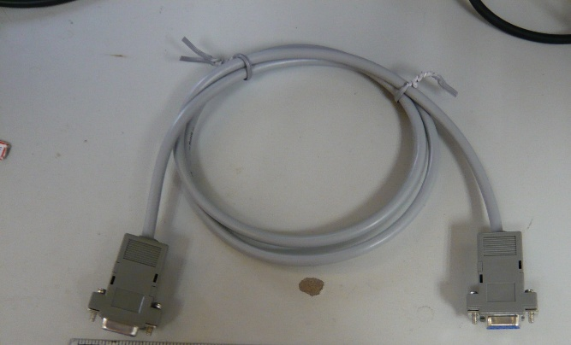

- AOM-5721 can communicate with a host server using serial cables. Common serial communication programs such as HyperTerminal, Tera Term or PuTTY can be used in such applications. The example demonstrated below describes the serial terminal setup using Tera Term on a Windows host: Open Tera Term on your Windows PC, and select the settings as shown in figure.

- Connect a Display:
The default display is the HDMI + DP output and the Weston UI will be displayed on the screen. If you need the eDP + DP or DSI + DP (Need the DSI AOM-5721 top board SKU) output, you can use the following tool to change it.
  - eDP + DP
# /tools/cdt/eMMCChangeToEDPwithSGTL5000.sh
or
# /tools/cdt/ufsChangeToEDPwithSGTL5000.sh
  - DSI + DP (Need the DSI AOM-5721 top board SKU)
# /tools/cdt/eMMCChangeToDSIwithWCD9385.sh
or
# /tools/cdt/ufsChangeToDSIwithWCD9385.sh

If you need to change back to HDMI + DP, you can use the following tool to change it.
# /tools/cdt/eMMCChangeToHDMI.sh
or
# /tools/cdt/ufsChangeToHDMI.sh
- Connect the Power Source:
- AOM-DB6700’s power input is 24VDC. Please choose a suitable adapter and power cord to connect the board (please refer to P/Ns on datasheet and Optional Accessories of this manual) as shown in Figure 2.25.
DP &

DC-In

- When switching on the power, the green LED indicator on BOT side of the board will light up to indicate that the board has booted up normally.

1 LED
2 LEDs

- Power on and login

Follow these steps to connect the device to the host machine through UART.
- Connect the debug cable to the "COME Debug" and connect the device to the host machine
- Connect the 12V power adapter to "12V DC-IN"
- Push the "Power Button" to power on the device
- Use the serial COM tool, such as PuTTY or Tera Term and set "Speed" to 115200
- View the serial log dump on your console
- Log in with account and password
Account: root
Password: oelinux123

Chapter 3

Software Functionality
This chapter details the software functions on the AOM-5721.

  - Display

The default display is the HDMI + DP output and the Weston UI will be displayed on the screen. If you need the eDP + DP or DSI + DP (Need the DSI AOM-5721 top board SKU) output, you can use the following tool to change it.
    - eDP + DP
# /tools/cdt/eMMCChangeToEDPwithSGTL5000.sh
or
# /tools/cdt/ufsChangeToEDPwithSGTL5000.sh

    - DSI + DP (Need the DSI AOM-5721 top board SKU)

# /tools/cdt/eMMCChangeToDSIwithWCD9385.sh
or
# /tools/cdt/ufsChangeToDSIwithWCD9385.sh

If you need to change back to HDMI + DP, you can use the following tool to change it.

# /tools/cdt/eMMCChangeToHDMI.sh
or
# /tools/cdt/ufsChangeToHDMI.sh

    - HDMI
AOM-DB6700 HW Setting:
- Connect to HDMI0_DP1
- J1 Jumper set to (1-2) : HDMI0
If you need to change back to HDMI + DP, you can use the following tool to change it.

# /tools/cdt/eMMCChangeToHDMI.sh
or
# /tools/cdt/ufsChangeToHDMI.sh
LE GA 1.1 can't support the Dynamic Resolution Switch, now. And it only support the 1080P@60 by default.
It can switch the 4K@30, 1080P@60, 720P@60 and 480P@60 timing by the following command.
- Manually Switch to 4K@30
# echo 3840 2160 30 > /sys/bus/i2c/drivers/lt9611uxc/1-002b/edid_mode
# systemctl restart init_display.service

- Manually Switch to 1080P@60
# echo 1920 1080 60 > /sys/bus/i2c/drivers/lt9611uxc/1-002b/edid_mode
# systemctl restart init_display.service

- Manually Switch to 720P@60
# echo 1280 720 60 > /sys/bus/i2c/drivers/lt9611uxc/1-002b/edid_mode
# systemctl restart init_display.service

- Manually Switch to 480P@60
# echo 720 480 60 > /sys/bus/i2c/drivers/lt9611uxc/1-002b/edid_mode
# systemctl restart init_display.service

For the HDMI plug-in/plug-out status, you can check the following
# cat /sys/class/drm/card0-DSI-1/status

    - eDP
It can support the following eDP panels:

15.6" Innolux N156HCE-EN1 (VDD:3.3V, Backlight Power:12V)

AOM-DB6700 HW Setting for this panel:
- Connect to LVDS0, LVDS0_BL
- J5 Jumper set to (3-5) : +3V3
- J6 Jumper set to (2-3) : EDP_HPD
- J7 Jumper set to (2-3) : +12V

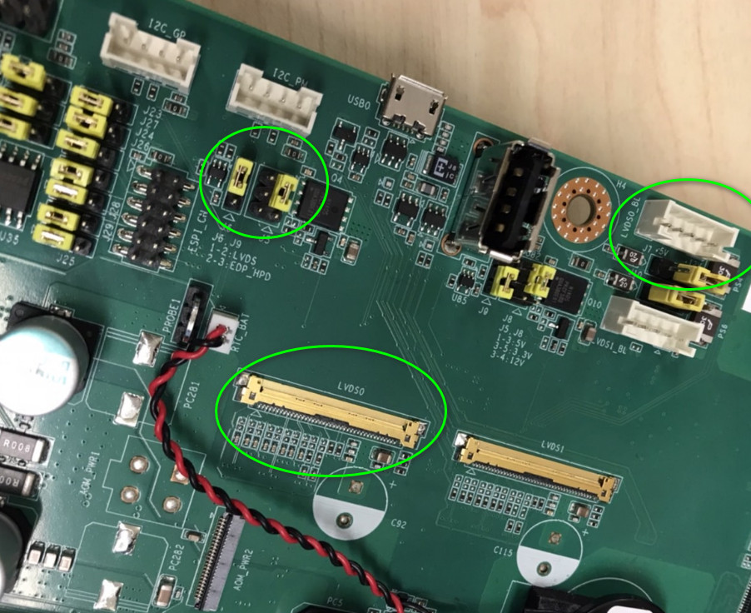

If you need the eDP + DP output, you can use the following tool to change it.
# /tools/cdt/eMMCChangeToEDPwithSGTL5000.sh
or
# /tools/cdt/ufsChangeToEDPwithSGTL5000.sh

Backlight control function
# echo 0 > /sys/class/backlight/panel-backlight/brightness
# echo 50 > /sys/class/backlight/panel-backlight/brightness
# echo 100 > /sys/class/backlight/panel-backlight/brightness
    - DSI

It can support the following DSI panels:

10.1" Auo G101UAN02.0 (VDD:3.3V, Backlight Power:12V)

AOM-DB6700 HW Setting for this panel:
- Connect to LVDS1, LVDS0_BL
- J8 Jumper set to (3-5) : +3V3
- J9 Jumper set to (1-2) : LVDS
- J7 Jumper set to (2-3) : +12V

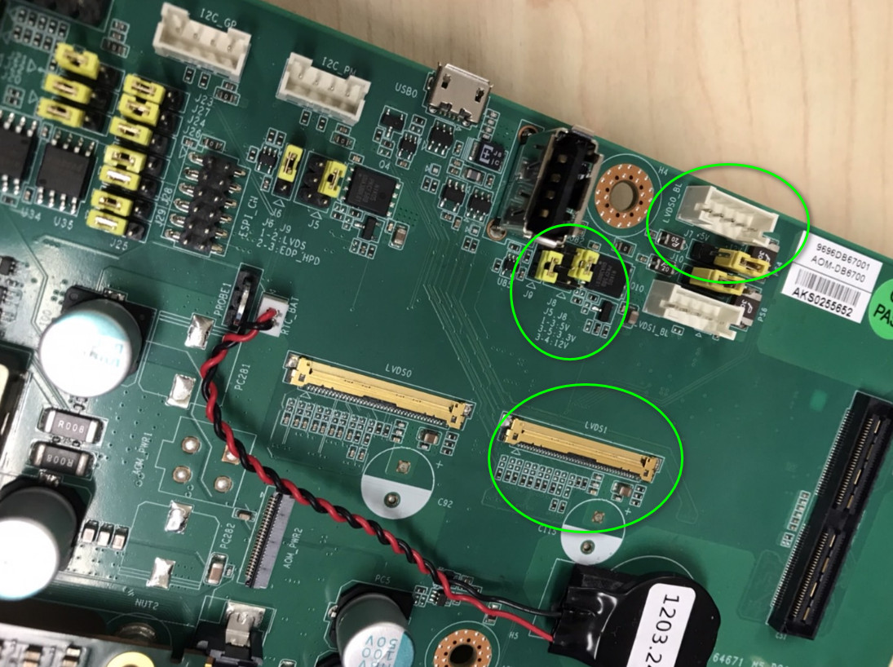

If you need the DSI + DP output, you can use the following tool to change it.
# /tools/cdt/eMMCChangeToDSIwithWCD9385.sh
or
# /tools/cdt/ufsChangeToDSIwithWCD9385.sh

Backlight control function
# echo 0 > /sys/class/backlight/panel-backlight/brightness
# echo 50 > /sys/class/backlight/panel-backlight/brightness
# echo 100 > /sys/class/backlight/panel-backlight/brightness
    - DP

It can support the maximum resolution is 4K@30.

For the DP plug-in/plug-out status, you can check the following
# cat /sys/class/drm/card0-DP-1/status

Switch to other resolution:
# echo 1920 1080 60 0 > /sys/kernel/debug/drm_dp/edid_modes
# echo 0 > /sys/kernel/debug/drm_dp/hpd
# echo 1 > /sys/kernel/debug/drm_dp/hpd

  - Audio

Connect the ROM-EG51 to the AOM-DB6700 I2S0 and boot up the device.
Connect the Mic In and Line Out to AOM-DB6700 AUDIO0
Default audio is hdmi audio.
For the SGTL5000, SW need to change to the CDT:

# /tools/cdt/ufsChangeToEDPwithSGTL5000.sh
or
# /tools/cdt/eMMCChangeToEDPwithSGTL5000.sh

HDMI
# pactl set-sink-port 0 headset
# pactl set-sink-port 1 headset
# paplay /tmp/audio_48k.wav
or
# pactl set-sink-port 0 headset
# pactl set-sink-port 1 headset
# source /opt/qcom/qirp-sdk/qirp-setup.sh
# gst-launch-1.0 -e filesrc location=/tmp/audio_48k.wav ! wavparse ! audioconvert ! pulsesink volume=5

Line-Out
# pactl set-sink-port 0 speaker
# pactl set-sink-port 1 speaker
# paplay /tmp/audio_48k.wav
or
# pactl set-sink-port 0 speaker
# pactl set-sink-port 1 speaker
# source /opt/qcom/qirp-sdk/qirp-setup.sh
# gst-launch-1.0 -e filesrc location=/tmp/audio_48k.wav ! wavparse ! audioconvert ! pulsesink volume=1

Mic-In
# tinymix set "Mic Volume" 3
# pactl set-source-port regular2 speaker-mic
# parec -v --rate=48000 --format=s16le --channels=1 --file-format=wav /tmp/audio_48k.wav --device=regular2
or
# tinymix set "Mic Volume" 3
# pactl set-source-port regular2 speaker-mic
# source /opt/qcom/qirp-sdk/qirp-setup.sh
# gst-launch-1.0 -v pulsesrc volume=1 ! audioconvert ! wavenc ! filesink location=/tmp/audio_48k.wav

  - Storages
eMMC: /dev/mmcblk0
SD Card: /dev/mmcblk1
UFS: /dev/sda, /dev/sdb ...
SPI Flash: /dev/mtd0, /dev/mtd1, /dev/mtd2, /dev/mtd3, /dev/mtd4 and /dev/mtd5
    - EMMC

# dd if=/dev/urandom of=data bs=1 count=1024
# dd if=/dev/mmcblk0 of=backup bs=1 count=1024 skip=4096
# dd if=data of=/dev/mmcblk0 bs=1 seek=4096
# dd if=/dev/mmcblk0 of=data1 bs=1 count=1024 skip=4096
# diff data data1
# dd if=backup of=/dev/mmcblk0 bs=1 seek=4096

    - SD Card

Connect the Micro SD card to the AOM-DB6700 SD.
# dd if=/dev/urandom of=data bs=1 count=1024
# dd if=/dev/mmcblk1 of=backup bs=1 count=1024 skip=4096
# dd if=data of=/dev/mmcblk1 bs=1 seek=4096
# dd if=/dev/mmcblk1 of=data1 bs=1 count=1024 skip=4096
# diff data data1
# dd if=backup of=/dev/mmcblk1 bs=1 seek=4096

    - UFS
Need to do the UFS Provision, first.
# dd if=/dev/urandom of=data bs=1 count=1024
# dd if=/dev/sda of=backup bs=1 count=1024 skip=4096
# dd if=data of=/dev/sda bs=1 seek=4096
# dd if=/dev/sda of=data1 bs=1 count=1024 skip=4096
# diff data data1
# dd if=backup of=/dev/sda bs=1 seek=4096

    - SPI Flash
# dd if=/dev/urandom of=data bs=1 count=1024
# dd if=/dev/mtd0 of=backup bs=1 count=1024 skip=4096
# dd if=data of=/dev/mtd0 bs=1 seek=4096
# dd if=/dev/mtd0 of=data1 bs=1 count=1024 skip=4096
# diff data data1
# dd if=backup of=/dev/mtd0 bs=1 seek=4096

  - RS232 Look back

    - AOM-DB6700 COM 0
Set AOM-DB6700 SW3 to 1-on, 2-off
# stty -F /dev/ttyHS1 -echo -onlcr 115200 raw
# cat /dev/ttyHS1 &
# echo "Serial Port Test" > /dev/ttyHS1

    - AOM-DB6700 COM 2

Set AOM-DB6700 SW4 to 1-on, 2-off

# stty -F /dev/ttyHS2 -echo -onlcr 115200 raw
# cat /dev/ttyHS2 &
# echo "Serial Port Test" > /dev/ttyHS2

    - AOM-DB6700 COM 1
# stty -F /dev/ttyHS3 -echo -onlcr 115200 raw
# cat /dev/ttyHS3 &
# echo "Serial Port Test" > /dev/ttyHS3

  - RS-422
Test RS-422 with AOM-DB6700: COM0 and AOM-DB6700: COM2 by RS-422 cable
Set AOM-DB6700 SW3 to 1-on, 2-on, 3-off, 4-on, 5-on, 6-off
Set AOM-DB6700 SW4 to 1-on, 2-on, 3-off, 4-on, 5-on, 6-off
    - AOM-DB6700 COM 0

Set AOM-DB6700 SW4 to 1-on, 2-on, 3-off, 4-on, 5-on, 6-off
# stty -F /dev/ttyHS1 speed 115200 ignbrk -brkint -icrnl -imaxbel -opost -onlcr -isig -icanon -iexten -echo -echoe -echok -echoctl -echoke
# cat /dev/ttyHS1 &
# echo "Serial Test" > /dev/ttyHS1
# echo -e "123456789-123456789-123456789-123456789-123456789-\r" | tee /dev/ttyHS1

    - AOM-DB6700: COM2
# stty -F /dev/ttyHS2 speed 115200 ignbrk -brkint -icrnl -imaxbel -opost -onlcr -isig -icanon -iexten -echo -echoe -echok -echoctl -echoke
# cat /dev/ttyHS2 &
# echo "Serial Test" > /dev/ttyHS2
# echo -e "123456789-123456789-123456789-123456789-123456789-\r" | tee /dev/ttyHS2

  - RS-485
Test RS-485 with AOM-DB6700: COM0 and AOM-DB6700: COM2 by RS-485 cable (parallel cable)
Set AOM-DB6700 SW3 to 1-off, 2-on, 3-off, 4-on, 5-on, 6-off
Set AOM-DB6700 SW4 to 1-off, 2-on, 3-off, 4-on, 5-on, 6-off

    - AOM-DB6700: COM0
# stty -F /dev/ttyHS1 speed 115200 ignbrk -brkint -icrnl -imaxbel -opost -onlcr -isig -icanon -iexten -echo -echoe -echok -echoctl -echoke
# cat /dev/ttyHS1 &
# echo "Serial Test" > /dev/ttyHS1
# echo -e "123456789-123456789-123456789-123456789-123456789-\r" | tee /dev/ttyHS1

    - AOM-DB6700: COM2
# stty -F /dev/ttyHS2 speed 115200 ignbrk -brkint -icrnl -imaxbel -opost -onlcr -isig -icanon -iexten -echo -echoe -echok -echoctl -echoke
# cat /dev/ttyHS2 &
# echo "Serial Test" > /dev/ttyHS2
# echo -e "123456789-123456789-123456789-123456789-123456789-\r" | tee /dev/ttyHS2

Chapter 3
Software Functionality
  - GPIO

AOM-DB6700: GPIO (17 pins)

GPIO0_1V8: gpio 676 (GPIO_141)

GPIO1_1V8: gpio 677 (GPIO_142)

GPIO2_1V8: gpio 555(GPIO_20)

GPIO3_1V8: gpio 556 (GPIO_21)

GPIO4_1V8: gpio 543 (GPIO_8)

GPIO5_1V8: gpio 546 (GPIO_11)

GPIO6_1V8: gpio 550 (GPIO_15)

GPIO7_1V8: gpio 551 (GPIO_16)

GPIO8_1V8: gpio 553 (GPIO_18)

GPIO9_1V8: gpio 554 (GPIO_19)

GPIO10_1V8: gpio 570 (GPIO_35)

GPIO11_1V8: gpio 579 (GPIO_44)

GPIO12_1V8: gpio 603 (GPIO_68)

GPIO13_1V8: gpio 639 (GPIO_104)

GPIO14_1V8: gpio 647 (GPIO_112)

GPIO16_1V8: gpio 544 (GPIO_9)

GPIO17_1V8: gpio 646 (GPIO_111)

GPIO0_1V8 and GPIO1_1V8 Loopback Test
- Connect the GPIO_A_0 and GPIO_A_1
- Export the GPIO interface
# echo 676 > /sys/class/gpio/export
# echo 677 > /sys/class/gpio/export

- Set the GPIO direction
# echo out > /sys/class/gpio/gpio676/direction
# echo in > /sys/class/gpio/gpio677/direction

- Set output value and check
# cat /sys/class/gpio/gpio677/value
0
# echo 1 > /sys/class/gpio/gpio676/value
# cat /sys/class/gpio/gpio677/value
1

Chapter 3
Software Functionality

  - Ethernet

Check Ethernet
# ifconfig
enP1p5s0f0 Link encap:Ethernet HWaddr EE:A9:36:72:A7:B9
inet addr:172.22.12.138 Bcast:172.22.15.255 Mask:255.255.252.0
inet6 addr: fe80::2009:4a63:5a32:d2ab/64 Scope:Link
inet6 addr: fe80::eca9:36ff:fe72:a7b9/64 Scope:Link
UP BROADCAST RUNNING MULTICAST MTU:1500 Metric:1
RX packets:118 errors:0 dropped:10 overruns:0 frame:0
TX packets:37 errors:0 dropped:0 overruns:0 carrier:0
collisions:0 txqueuelen:1000
RX bytes:27625 (26.9 KiB) TX bytes:6142 (5.9 KiB)
Interrupt:239

enP1p5s0f1 Link encap:Ethernet HWaddr EE:51:3E:06:D5:3C
UP BROADCAST MULTICAST MTU:1500 Metric:1
RX packets:0 errors:0 dropped:0 overruns:0 frame:0
TX packets:0 errors:0 dropped:0 overruns:0 carrier:0
collisions:0 txqueuelen:1000
RX bytes:0 (0.0 B) TX bytes:0 (0.0 B)
Interrupt:244

lo Link encap:Local Loopback
inet addr:127.0.0.1 Mask:255.0.0.0
inet6 addr: ::1/128 Scope:Host
UP LOOPBACK RUNNING MTU:65536 Metric:1
RX packets:18 errors:0 dropped:0 overruns:0 frame:0
TX packets:18 errors:0 dropped:0 overruns:0 carrier:0
collisions:0 txqueuelen:1000
RX bytes:2272 (2.2 KiB) TX bytes:2272 (2.2 KiB)

Ping Test
# ping 8.8.8.8
PING 8.8.8.8 (8.8.8.8): 56 data bytes
64 bytes from 8.8.8.8: icmp_seq=0 ttl=113 time=5.320 ms
64 bytes from 8.8.8.8: icmp_seq=1 ttl=113 time=7.445 ms
64 bytes from 8.8.8.8: icmp_seq=2 ttl=113 time=7.367 ms
64 bytes from 8.8.8.8: icmp_seq=3 ttl=113 time=7.431 ms
64 bytes from 8.8.8.8: icmp_seq=4 ttl=113 time=6.394 ms

Ethernet LED Lights Test
- Link LED Light
- 10M - orange and green light: always off
- 100M - orange light: always on
- 1000M - green light: always on
- Active LED Light
- 10M - green light: flashing on
- 100M - green light: flashing on
- 1000M - green light: flashing on

10M Speed Setting
# ethtool -s enP1p5s0f0 speed 10 duplex full
# ethtool -s enP1p5s0f1 speed 10 duplex full

100M Speed Setting
# ethtool -s enP1p5s0f0 speed 100 duplex full
# ethtool -s enP1p5s0f1 speed 100 duplex full

1000M Speed Setting
# ethtool -s enP1p5s0f0 speed 1000 duplex full
# ethtool -s enP1p5s0f1 speed 1000 duplex full

  - Can Fd
You can connect the AOM-DB6700 CAN0/1 to a parallel cable.
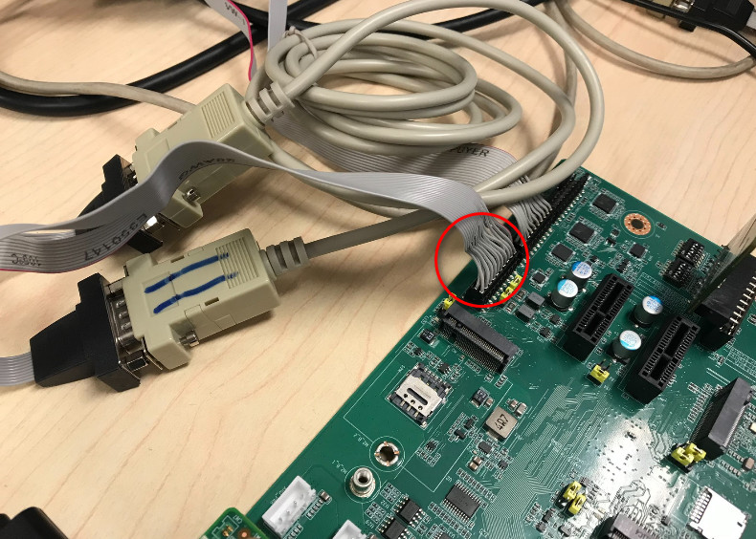
    - Can Fd Test

# ip link set can0 up type can bitrate 1000000 dbitrate 8000000 fd on
# ip link set can1 up type can bitrate 1000000 dbitrate 8000000 fd on
# candump can0 &
# cansend can1 123##300112233445566778899aabbccddeeff
can0 123 [16] 00 11 22 33 44 55 66 77 88 99 AA BB CC DD EE FF

    - USB
- Micro USB: AOM-DB6700 USB0
- USB 2.0 Type A: AOM-DB6700 USB3/4

Micro USB

Micro USB can used for the EDL download. If you need to use the adb or fastboot, you need to set the Micro USB to device mode.
# echo 621 > /sys/class/gpio/export
# echo out > /sys/class/gpio/gpio621/direction
# echo 0 > /sys/class/gpio/gpio621/value
# echo device > /sys/kernel/debug/usb/a600000.usb/mode

USB 2.0 Type A

You can insert the USB 2.0/3.0 flash drive to the USB 2.0 Type A.

Check the USB flash drive
# lsusb -t
/: Bus 03.Port 1: Dev 1, Class=root_hub, Driver=xhci-hcd/1p, 5000M
|__ Port 1: Dev 2, If 0, Class=Hub, Driver=hub/4p, 5000M
|__ Port 1: Dev 4, If 0, Class=Mass Storage, Driver=usb-storage, 5000M
/: Bus 02.Port 1: Dev 1, Class=root_hub, Driver=xhci-hcd/1p, 480M
/: Bus 01.Port 1: Dev 1, Class=root_hub, Driver=xhci-hcd/1p, 480M
|__ Port 1: Dev 2, If 0, Class=Hub, Driver=hub/4p, 480M
|__ Port 2: Dev 7, If 0, Class=Mass Storage, Driver=usb-storage, 480M

USB Flash Drive Read/Write
# dd if=/dev/urandom of=data bs=1 count=1024
# dd if=/dev/sda of=backup bs=1 count=1024 skip=4096
# dd if=data of=/dev/sda bs=1 seek=4096
# dd if=/dev/sda of=data1 bs=1 count=1024 skip=4096
# diff data data1
# dd if=backup of=/dev/sda bs=1 seek=4096

  - I2C
- I2C 0 (QPS615_I2C):
0x77: QPS615
- I2C 1 (APPS_I2C -> AOM-DB6700: I2C_PM):
0x27: TCA9555PWR GPIO Expandor
0x2B: LT9611UXC (DSI to HDMI bridge)
0x2E: TPM
0x32: RTC
0x50: EEPROM
0x53: EEPROM
0x6C: PCIe CLKGEN
0x71: ERP_MCU
- I2C 3 (I2C_A -> AOM-DB6700: I2C_GP):
0x0A: SGTL5000 (Audio Codec)
0x27: TCA9555PWR GPIO Expandor
0x57: EEPROM
- I2C 9 (I2C_B -> AOM-DB6700: I2C_LCD):
LCD
- I2C Detect

# i2cdetect -y -r 0
0 1 2 3 4 5 6 7 8 9 a b c d e f
00: -- -- -- -- -- -- -- -- -- -- -- -- --
10: -- -- -- -- -- -- -- -- -- -- -- -- -- -- -- --
20: -- -- -- -- -- -- -- -- -- -- -- -- -- -- -- --
30: -- -- -- -- -- -- -- -- -- -- -- -- -- -- -- --
40: -- -- -- -- -- -- -- -- -- -- -- -- -- -- -- --
50: -- -- -- -- -- -- -- -- -- -- -- -- -- -- -- --
60: -- -- -- -- -- -- -- -- -- -- -- -- -- -- -- --
70: -- -- -- -- -- -- -- UU

# i2cdetect -y -r 1
0 1 2 3 4 5 6 7 8 9 a b c d e f
00: -- -- -- -- -- -- -- --
10: -- -- -- -- -- -- -- -- -- -- -- -- -- -- -- --
20: -- -- -- -- -- -- -- UU -- -- -- UU -- -- UU --
30: -- -- UU -- -- -- -- -- -- -- -- -- -- -- -- --
40: -- -- -- -- 44 -- -- -- -- -- -- -- -- -- -- --
50: UU -- -- 53 -- -- -- -- -- -- -- -- -- -- -- --
60: -- -- -- -- -- -- -- -- -- -- -- -- 6c 6d -- --
70: -- 71 -- -- -- -- -- --

# i2cdetect -y -r 3
0 1 2 3 4 5 6 7 8 9 a b c d e f
00: -- -- UU -- -- -- -- --
10: -- -- -- -- -- -- -- -- -- -- -- -- -- -- -- --
20: -- -- -- -- -- -- -- UU -- -- -- -- -- -- -- --
30: -- -- -- -- -- -- -- -- -- -- -- -- -- -- -- --
40: -- -- -- -- -- -- -- -- -- -- -- -- -- -- -- --
50: -- -- -- -- -- -- -- 57 -- -- -- -- -- -- -- --
60: -- -- -- -- -- -- -- -- -- -- -- -- -- -- -- --
70: -- -- -- -- -- -- -- --

# i2cdetect -y -r 9
0 1 2 3 4 5 6 7 8 9 a b c d e f
00: -- -- -- -- -- -- -- -- -- -- -- -- --
10: -- -- -- -- -- -- -- -- -- -- -- -- -- -- -- --
20: -- -- -- -- -- -- -- -- -- -- -- -- -- -- -- --
30: -- -- -- -- -- -- -- -- -- -- -- -- -- -- -- --
40: -- -- -- -- -- -- -- -- -- -- -- -- -- -- -- --
50: -- -- -- -- -- -- -- -- -- -- -- -- -- -- -- --
60: -- -- -- -- -- -- -- -- -- -- -- -- -- -- -- --
70: -- -- -- -- -- -- -- --

  - External RTC

Set system time to current, then write to RTC
# date 032010452024 && hwclock -w && date
Wed Mar 20 10:45:00 UTC 2024
Wed Mar 20 10:45:01 UTC 2024

Set one incorrect time, then read time from RTC to verify
# date 010100002000 && hwclock -r && date
Sat Jan 1 00:00:00 UTC 2000
2024-03-20 10:47:33.749407+00:00
Sat Jan 1 00:00:00 UTC 2000

Restore the RTC time to system time
# hwclock -s && date
Wed Mar 20 10:49:03 UTC 2024

Chapter 3
Software Functionality
  - Internal Watchdog

The system will reboot after the system crash about 7 seconds by the following command:
# echo c > /proc/sysrq-trigger

  - Camera
AOM-EC-91 CAM0: 2-lane MIPI CSI (OV9282)
AOM-EC-91 CAM1: 4-lane MIPI CSI (IMX577)
AOM-EC-91 CAM2: 4-lane MIPI CSI (IMX577)
AOM-EC-91 CAM3: 4-lane MIPI CSI (IMX577)

AOM-EC-91 CAM0: 2-lane MIPI CSI (OV9282)

Preview

1280x720@30:
# source /opt/qcom/qirp-sdk/qirp-setup.sh
# export XDG_RUNTIME_DIR=/dev/socket/weston && export WAYLAND_DISPLAY=wayland-1 && gst-launch-1.0 -e qtiqmmfsrc camera=0 name=camsrc ! video/x-raw,format=NV12,width=1280,height=720,framerate=30/1 ! waylandsink fullscreen=true async=true sync=false

AOM-EC-91 CAM1: 4-lane MIPI CSI (IMX577)

Preview
(1) 3840x2160@30:
# source /opt/qcom/qirp-sdk/qirp-setup.sh
# export XDG_RUNTIME_DIR=/dev/socket/weston && export WAYLAND_DISPLAY=wayland-1 && gst-launch-1.0 -e qtiqmmfsrc camera=1 name=camsrc ! video/x-raw,format=NV12,width=3840,height=2160,framerate=30/1 ! waylandsink fullscreen=true async=true sync=false

(2) 1920x2160@30:
# source /opt/qcom/qirp-sdk/qirp-setup.sh
# export XDG_RUNTIME_DIR=/dev/socket/weston && export WAYLAND_DISPLAY=wayland-1 && gst-launch-1.0 -e qtiqmmfsrc camera=1 name=camsrc ! video/x-raw,format=NV12,width=1920,height=1080,framerate=30/1 ! waylandsink fullscreen=true async=true sync=false

AOM-EC-91 CAM2: 4-lane MIPI CSI (IMX577)

Preview
(1) 3840x2160@30:

# source /opt/qcom/qirp-sdk/qirp-setup.sh
# export XDG_RUNTIME_DIR=/dev/socket/weston && export WAYLAND_DISPLAY=wayland-1 && gst-launch-1.0 -e qtiqmmfsrc camera=2 name=camsrc ! video/x-raw,format=NV12,width=3840,height=2160,framerate=30/1 ! waylandsink fullscreen=true async=true sync=false
(2) 1920x2160@30:
# source /opt/qcom/qirp-sdk/qirp-setup.sh
# export XDG_RUNTIME_DIR=/dev/socket/weston && export WAYLAND_DISPLAY=wayland-1 && gst-launch-1.0 -e qtiqmmfsrc camera=2 name=camsrc ! video/x-raw,format=NV12,width=1920,height=1080,framerate=30/1 ! waylandsink fullscreen=true async=true sync=false

AOM-EC-91 CAM3: 4-lane MIPI CSI (IMX577)

Preview
(1) 3840x2160@30:
# source /opt/qcom/qirp-sdk/qirp-setup.sh
# export XDG_RUNTIME_DIR=/dev/socket/weston && export WAYLAND_DISPLAY=wayland-1 && gst-launch-1.0 -e qtiqmmfsrc camera=3 name=camsrc ! video/x-raw,format=NV12,width=3840,height=2160,framerate=30/1 ! waylandsink fullscreen=true async=true sync=false
(2) 1920x2160@30:
# source /opt/qcom/qirp-sdk/qirp-setup.sh
# export XDG_RUNTIME_DIR=/dev/socket/weston && export WAYLAND_DISPLAY=wayland-1 && gst-launch-1.0 -e qtiqmmfsrc camera=3 name=camsrc ! video/x-raw,format=NV12,width=1920,height=1080,framerate=30/1 ! waylandsink fullscreen=true async=true sync=false

Multi Camera Preview
# source /opt/qcom/qirp-sdk/qirp-setup.sh
# export XDG_RUNTIME_DIR=/dev/socket/weston
# export WAYLAND_DISPLAY=wayland-1
# echo "performance" > /sys/devices/system/cpu/cpu0/cpufreq/scaling_governor
# echo "performance" > /sys/devices/system/cpu/cpu1/cpufreq/scaling_governor
# echo "performance" > /sys/devices/system/cpu/cpu2/cpufreq/scaling_governor
# echo "performance" > /sys/devices/system/cpu/cpu3/cpufreq/scaling_governor
# echo "performance" > /sys/devices/system/cpu/cpu4/cpufreq/scaling_governor
# echo "performance" > /sys/devices/system/cpu/cpu5/cpufreq/scaling_governor
# echo "performance" > /sys/devices/system/cpu/cpu6/cpufreq/scaling_governor
# echo "performance" > /sys/devices/system/cpu/cpu7/cpufreq/scaling_governor

# gst-launch-1.0 -e qtivcomposer name=mixer \
sink_0::position="<0, 0>" sink_0::dimensions="<1280, 800>" \
sink_1::position="<1280, 0>" sink_1::dimensions="<1280, 720>" \
sink_2::position="<0, 720>" sink_2::dimensions="<1280, 720>" \
sink_3::position="<1280, 720>" sink_3::dimensions="<1280, 720>" \
mixer. ! queue ! waylandsink enable-last-sample=false fullscreen=true \
qtiqmmfsrc video_0::type=preview name=camsrc_0 camera=0 ife-direct-stream=1 ! 'video/x-raw,format=NV12,width=1280,height=800,framerate=30/1' ! mixer. \
qtiqmmfsrc name=camsrc_1 camera=1 ! video/x-raw, format=NV12, width=1280, height=720, framerate=30/1 ! mixer. \
qtiqmmfsrc name=camsrc_2 camera=2 ! video/x-raw, format=NV12, width=1280, height=720, framerate=30/1 ! mixer. \
qtiqmmfsrc name=camsrc_3 camera=3 ! video/x-raw, format=NV12, width=1280, height=720, framerate=30/1 ! mixer.

Chapter 3
Software Functionality

  - M.2 Key E

Support the AIW-170BQ WIFI/BT module.

WIFI Connection
# lspci
0000:00:00.0 PCI bridge: Qualcomm Device 010b
0000:01:00.0 Network controller: Qualcomm QCNFA765 Wireless Network Adapter (rev 01)

# ifconfig wlp1s0
wlp1s0 Link encap:Ethernet HWaddr 00:0E:8E:BF:DE:0D
UP BROADCAST MULTICAST MTU:1500 Metric:1
RX packets:0 errors:0 dropped:0 overruns:0 frame:0
TX packets:0 errors:0 dropped:0 overruns:0 carrier:0
collisions:0 txqueuelen:1000
RX bytes:0 (0.0 B) TX bytes:0 (0.0 B)

# vi /etc/wpa_supplicant.conf
network={
ssid="Your SSID"
key_mgmt=WPA-PSK
proto=WPA RSN
auth_alg=OPEN
pairwise=TKIP CCMP
group=TKIP CCMP
psk="Your PASSWORD"
}

# wpa_supplicant -i wlp1s0 -Dnl80211 -c /etc/wpa_supplicant.conf &
# ping 8.8.8.8

# ifconfig wlp1s0
wlp1s0 Link encap:Ethernet HWaddr 00:0E:8E:BF:DE:0D
inet addr:172.20.10.8 Bcast:172.20.10.15 Mask:255.255.255.240
inet6 addr: 2401:e180:8880:3d43:16fb:957b:355e:884f/64 Scope:Global
inet6 addr: fe80::b1eb:b874:c798:be6/64 Scope:Link
UP BROADCAST RUNNING MULTICAST MTU:1500 Metric:1
RX packets:46 errors:0 dropped:0 overruns:0 frame:0
TX packets:110 errors:0 dropped:0 overruns:0 carrier:0
collisions:0 txqueuelen:1000
RX bytes:5116 (4.9 KiB) TX bytes:14985 (14.6 KiB)

# ping 8.8.8.8
PING 8.8.8.8 (8.8.8.8): 56 data bytes
64 bytes from 8.8.8.8: icmp_seq=0 ttl=53 time=61.347 ms
64 bytes from 8.8.8.8: icmp_seq=1 ttl=53 time=48.723 ms
64 bytes from 8.8.8.8: icmp_seq=2 ttl=53 time=46.027 ms
64 bytes from 8.8.8.8: icmp_seq=3 ttl=53 time=59.144 ms
64 bytes from 8.8.8.8: icmp_seq=4 ttl=53 time=49.458 ms

BT Connection
# hciconfig
hci0: Type: Primary Bus: USB
BD Address: 00:0E:8E:BC:4A:78 ACL MTU: 1024:7 SCO MTU: 240:8
DOWN
RX bytes:857 acl:0 sco:0 events:59 errors:0
TX bytes:579 acl:0 sco:0 commands:59 errors:0

# hciconfig hci0 up
# bluetoothctl
# discoverable on
# pairable on
# scan on
[NEW] FC:18:3C:8D:75:F4 myphone
# scan off
# pair FC:18:3C:8D:75:F4
# connect FC:18:3C:8D:75:F4

  - M.2 Key B
- Support the AIW-356 4G module.
- Need to insert the nano SIM card.

4G Connection
- AIW-356

# lsusb
Bus 003 Device 003: ID 2cb7:0104 Fibocom Fibocom FM160 Modem_SN:8AF6F50C (at+gtusbmode=32)
or
Bus 003 Device 004: ID 2cb7:0111 Fibocom Fibocom FM160 Modem_SN:8AF6F50C (at+gtusbmode=30)

# lsusb -t
/: Bus 03.Port 1: Dev 1, Class=root_hub, Driver=xhci-hcd/1p, 5000M
|__ Port 1: Dev 2, If 0, Class=Hub, Driver=hub/4p, 5000M
|__ Port 1: Dev 3, If 0, Class=Mass Storage, Driver=usb-storage, 5000M
|__ Port 3: Dev 4, If 0, Class=Communications, Driver=cdc_mbim, 5000M
|__ Port 3: Dev 4, If 1, Class=CDC Data, Driver=cdc_mbim, 5000M
|__ Port 3: Dev 4, If 2, Class=Vendor Specific Class, Driver=option, 5000M
|__ Port 3: Dev 4, If 3, Class=Vendor Specific Class, Driver=option, 5000M
|__ Port 3: Dev 4, If 4, Class=Vendor Specific Class, Driver=option, 5000M
/: Bus 02.Port 1: Dev 1, Class=root_hub, Driver=xhci-hcd/1p, 480M
/: Bus 01.Port 1: Dev 1, Class=root_hub, Driver=xhci-hcd/1p, 480M
|__ Port 1: Dev 2, If 0, Class=Hub, Driver=hub/4p, 480M

# ifconfig | grep wwan0
wwan0 Link encap:Ethernet HWaddr 36:B7:D9:18:79:41

1. Change to the MBIM + MODEM + DIAG + AT mode (One-time Prerequisite) for the AIW-356. Default is the DIAG + MODEM + AT + PIPE + RMNET mode.
# microcom -t 15000 -s 115200 /dev/ttyUSB2
at+gtusbmode=30

2. Use the MBIM to connect the internet:
# chmod u+w /sys/bus/usb-serial/drivers/option1/new_id
# echo "2cb7 0111" > /sys/bus/usb-serial/drivers/option1/new_id
# mbimcli -d /dev/cdc-wdm0 -p --query-connection-state
# mbimcli -d /dev/cdc-wdm0 -p --query-subscriber-ready-status
# mbimcli -d /dev/cdc-wdm0 -p --set-radio-state=on
//# mbimcli -d /dev/cdc-wdm0 -p --enter-pin=0000 (If needed)
# mbim-network /dev/cdc-wdm0 start
# mbimcli -d /dev/cdc-wdm0 -p --query-ip-configuration
# /tools/modem/mbim-set-ip /dev/cdc-wdm0 wwan0

# ifconfig wwan0
wwan0 Link encap:Ethernet HWaddr 36:B7:D9:18:79:41
inet addr:10.70.116.33 Bcast:10.70.116.35 Mask:255.255.255.252
inet6 addr: fe80::b126:f214:f57c:949/64 Scope:Link
inet6 addr: 2001:b400:e352:e30a:a370:edbb:d419:4996/64 Scope:Global
UP BROADCAST RUNNING NOARP MULTICAST MTU:1500 Metric:1
RX packets:5 errors:0 dropped:0 overruns:0 frame:0
TX packets:56 errors:81 dropped:0 overruns:0 carrier:0
collisions:0 txqueuelen:1000
RX bytes:1230 (1.2 KiB) TX bytes:7856 (7.6 KiB)

# ping 8.8.8.8
PING 8.8.8.8 (8.8.8.8): 56 data bytes
64 bytes from 8.8.8.8: icmp_seq=0 ttl=114 time=162.628 ms
64 bytes from 8.8.8.8: icmp_seq=1 ttl=114 time=49.067 ms
64 bytes from 8.8.8.8: icmp_seq=2 ttl=114 time=47.258 ms
64 bytes from 8.8.8.8: icmp_seq=3 ttl=114 time=50.771 ms
64 bytes from 8.8.8.8: icmp_seq=4 ttl=114 time=40.334 ms

  - M.2 Key M

Support the SQF-C8BV2-128GDEDC NVME SSD.
# lspci
# lsblk | grep nvme0
# mount /dev/nvme0n1p1 /mnt/
# vi /mnt/test
# cat /mnt/test

  - TPM

# dmesg | grep tpm
# /tools/tpm/tpm_test.bin
[TPM Command]
80010000000C000001440000
[TPM Response]
80010000000A00000100

[TPM Command]
80010000000B0000014301
[TPM Response]
80010000000A00000000

[TPM Command]
8001000000160000017A000000060000010500000001
[TPM Response]
80010000001B000000000100000006000000010000010553544D20

[TPM Command]
8001000000160000017A000000060000010B00000002
[TPM Response]
800100000023000000000100000006000000020000010B000901010000010C00000000

  - Power Button
- When the system is in the power off state, it can be power on by short pressing the Power Key.
- When the system is in the power on state, it can be power off by short pressing the Power Key.
- It can force shutdown by pressing and holding the Power Key for 5 seconds.

  - Reset Button
- The system will reset when pressing the Reset Key.

Chapter 4
Embedded O.S
This chapter details instructions for building Linux systems

Introduction
Advantech’s AOM-5721 comes preloaded with Yocto 4.0 based embedded
O.S., It contains all the system-required shell commands and drivers needed to operate the platform. We do not offer IDE developing environment on AOM-5721 BSP. Users can evaluate and develop their device using the Yocto 4.0 LTS environment.
This chapter introduces the software configuration and development of AOM-5721. It enables users to develop their application(s) efficiently.
For detailed operation, please refer to the Ubuntu Version A User Guide.
The following link directs you to the QCS6490 series Wikipedia page: https://ess-wiki.advantech.com.tw/view/AIM-Linux/BSP/Qualcomm/RISC_QCS_Linux_00011.1
.

Chapter 5

System Recovery
This chapter details system recovery procedures for a damaged Linux OS.

System Recovery
Using windows PCAT or Qualcomm Download (QDL) tool to flash software images to the device.

Emergency download (EDL) mode
- Connect the Micro USB (EDL) to your linux host computer.

- AOM-DB6700 SW2 (BOOT Selection)
    - Normal Boot: SW2 set to default 1-on, 2-off, 3-off, 4-off, 5-off, 6-off
    - Force Recovery (QDL Download): SW2 set to 1-on, 2-off, 3-off, 4-on, 5-off, 6-off

- Connect the adapter and power on the device

Windows PCAT Tool

Prepare
- Download the Qualcomm Software Center:
https://softwarecenter.qualcomm.com/#/catalog/item/Qualcomm_Software_Center
- Open the Qualcomm Software Center
- Search "PCAT" in the search bar
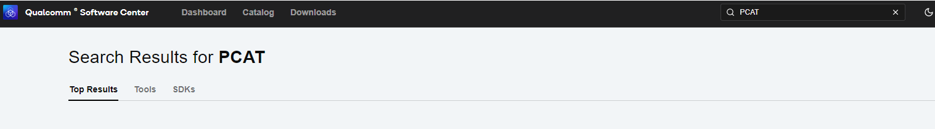

- Click Qualcomm® Product Configuration Assistant Tool
- Select Qualcomm® Product Configuration Assistant Tool versio : 2.33.2.119
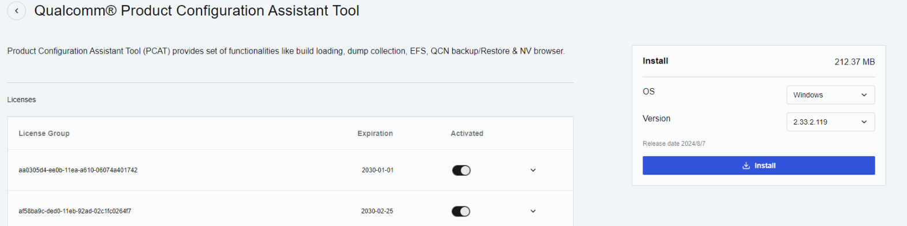

- Install Qualcomm® Product Configuration Assistant Tool 2.33.2.119
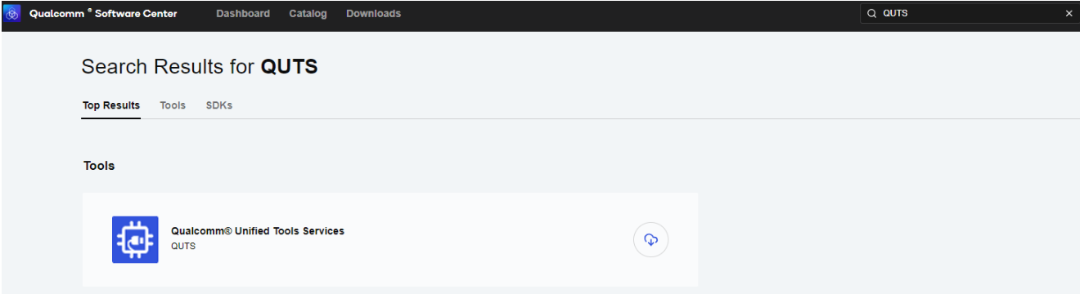
- Search "QUTS" in the search bar
- Click the Qualcomm® Unified Tools Services
- Select Qualcomm® Unified Tools Services version : 1.75.2.9
- Install Qualcomm® Unified Tools Services 1.75.2.9
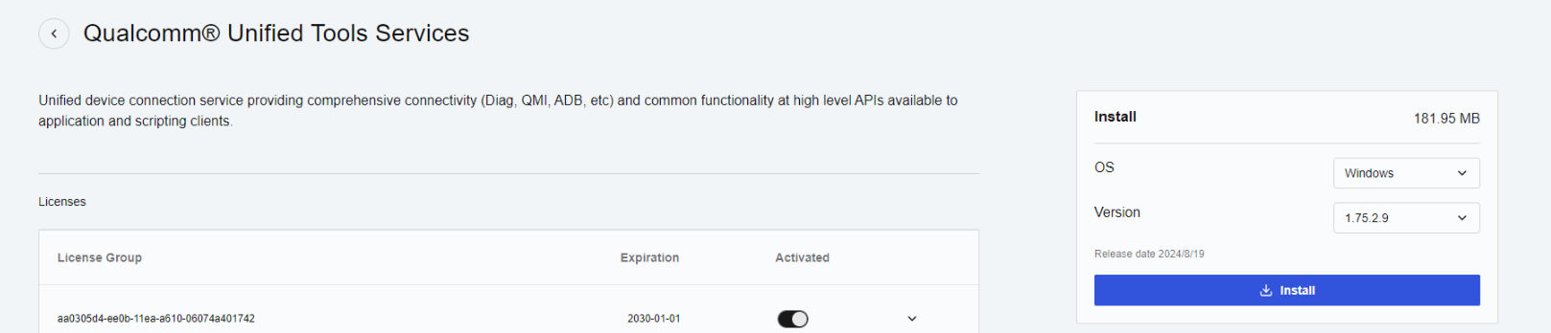

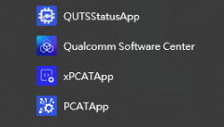
- You will find the new application in your Windows system .

- Unzip the UFS File and eMMC File
For example :
2860A1AIM38LIV11030_2024-11-18_ufs.tgz
2860A1AIM38LIV11030_2024-11-18_eMMC.tgz

- Connect your device via Micro USB.

UFS Provision
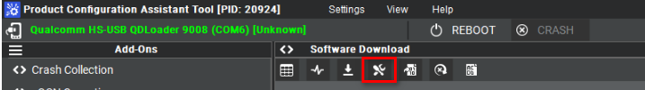
- Select provision button
- Add the prog_firehose_ddr.elf and provision_ufs31.xml in UFS folder.

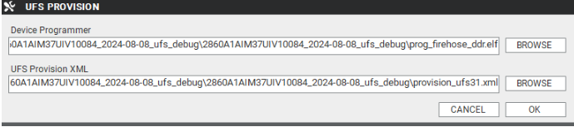
- Then press "OK" , it will start to do USF Provision.
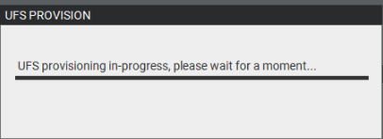

- When the Provision finished , you can see the result in message window.

Flash UFS
- Change the SW1 and SW2:
  - Flash UFS: the AOM-5721 SW1 set to 1-off
  - Forced Recovery: the AOM-5721 SW1 set to 2-on or AOM-DB6700 SW2 set to 4-on
- Turn on the power
- Open " PCATApp" Tool
- Click " Connect A Device"
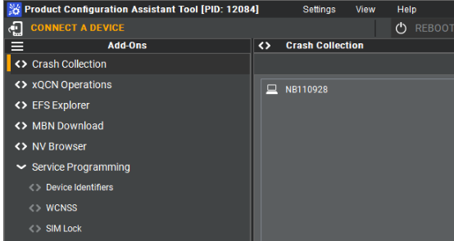
- Select "Qualcomm HS-USB QDLoader 9008 (COM6)
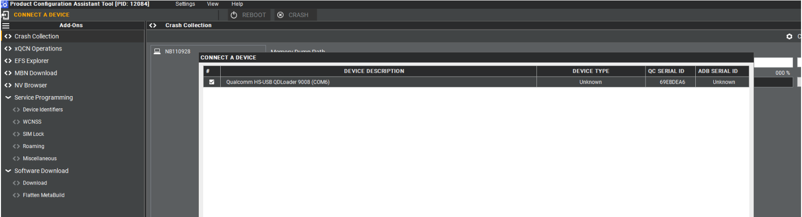

- Click " Connect " device
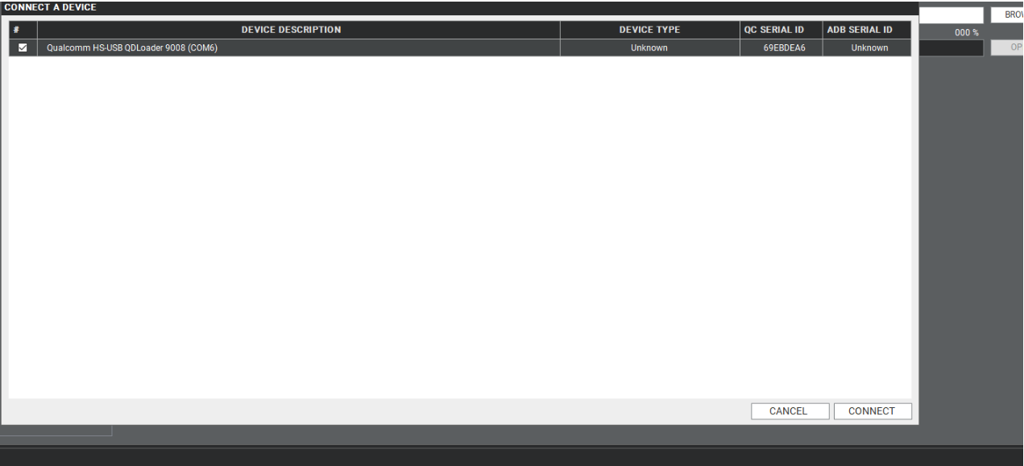

- When you connected successfully , it will show "green word" - Qualcomm HS-USB QDLoader 9008 (COM 6)

- Select UFS Folder in PCAT Tool , the Tool will help load Files automatically and Select "MEMORY_TYPE_UFS"
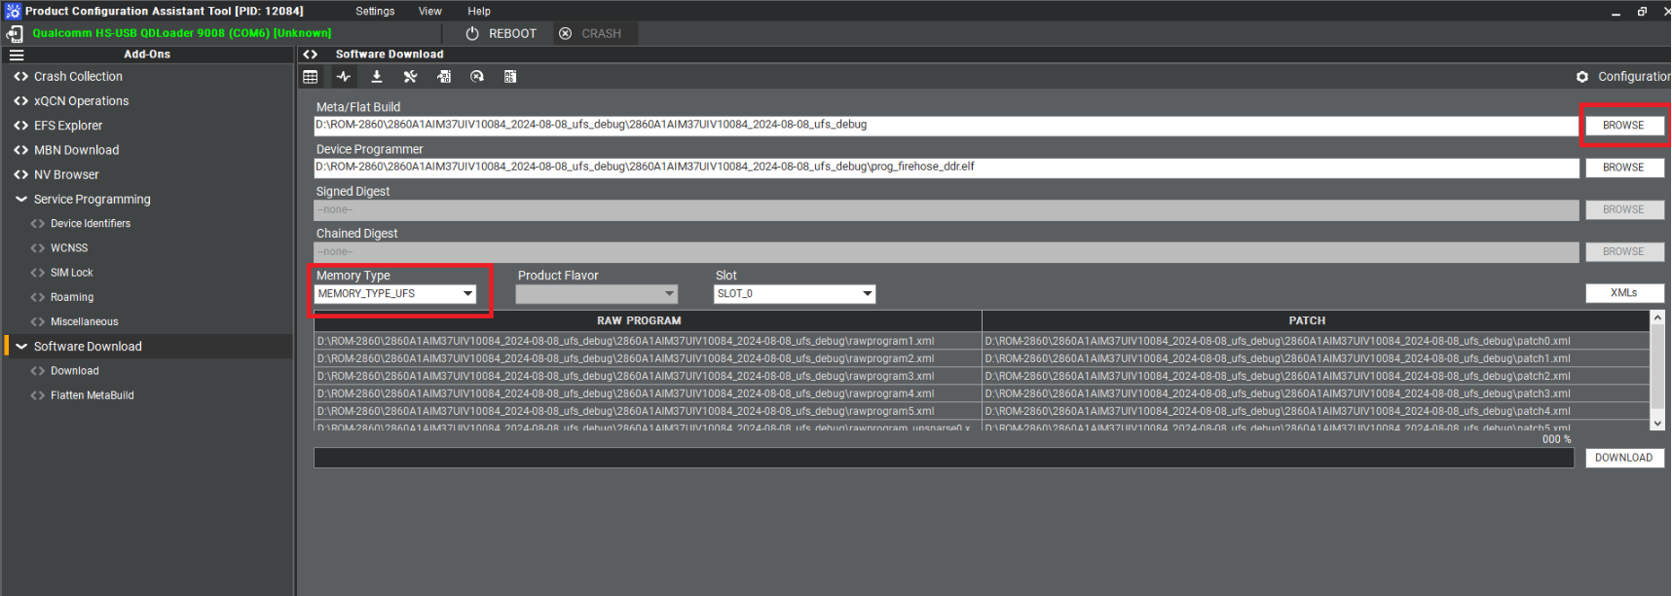
- Click " Download"
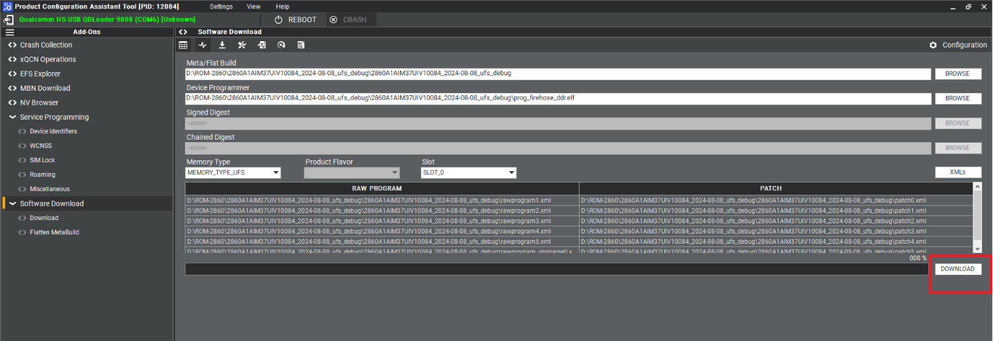
- UFS Download Status
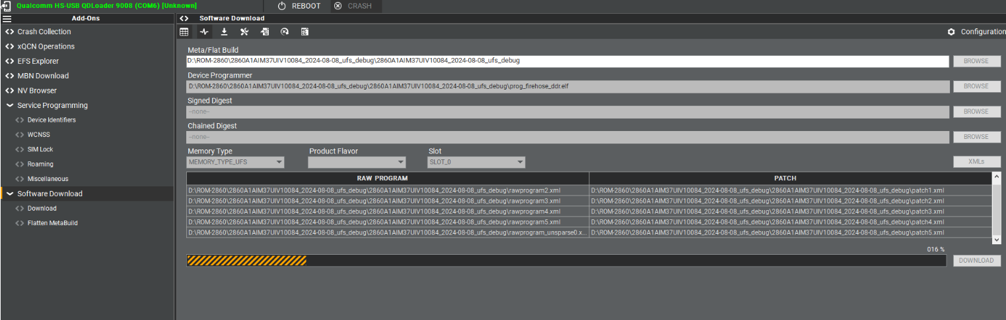
- UFS Download completed
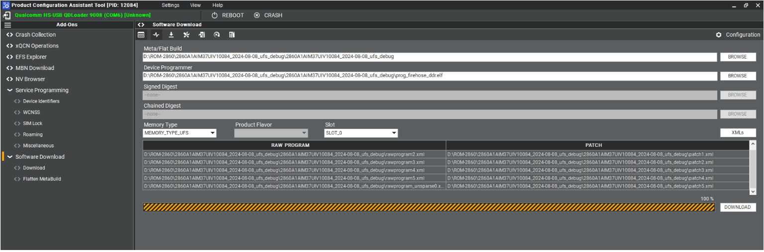

Flash EMMC
- Turn off the Power
- Change the SW1 and SW2
  - Flash eMMC: the AOM-5721 SW1 set to 1-on
  - Forced Recovery: the AOM-5721 SW1 set to 2-on or AOM-DB6700 SW2 set to 4-on
- Turn on the power
- Make sure the device connection status.
- If the device disconnect with PCAT Tool , please connect it again.
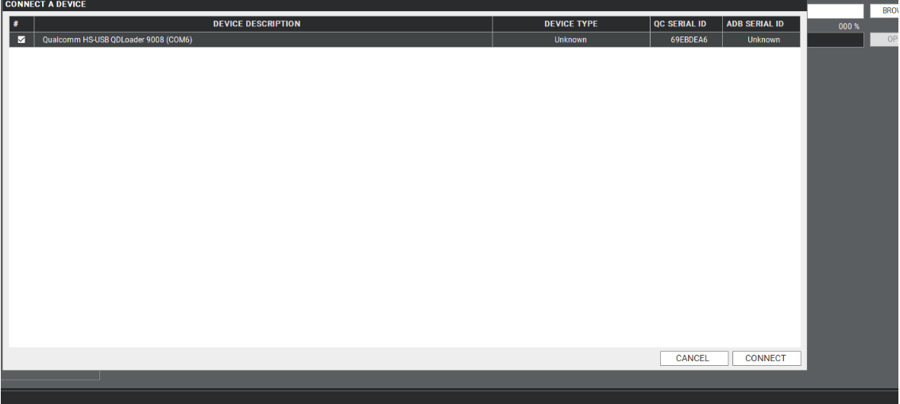
- Select EMMC Folder.
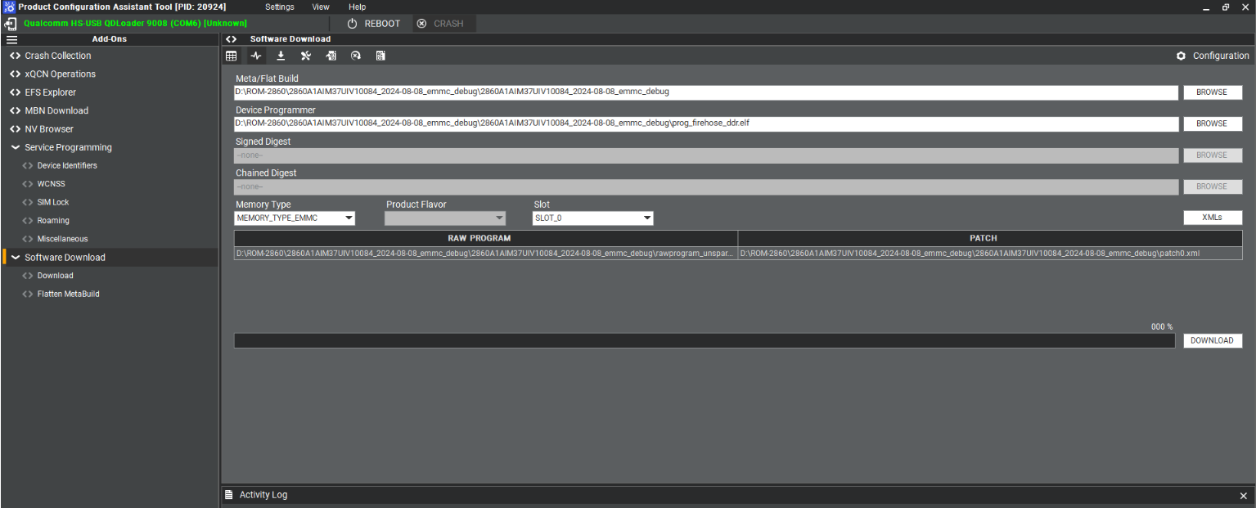
- Make sure the setting ,then press " Download " button.
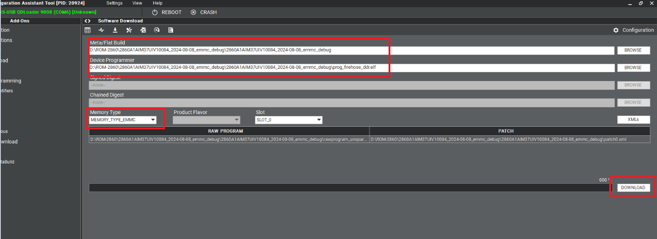
- EMMC download status
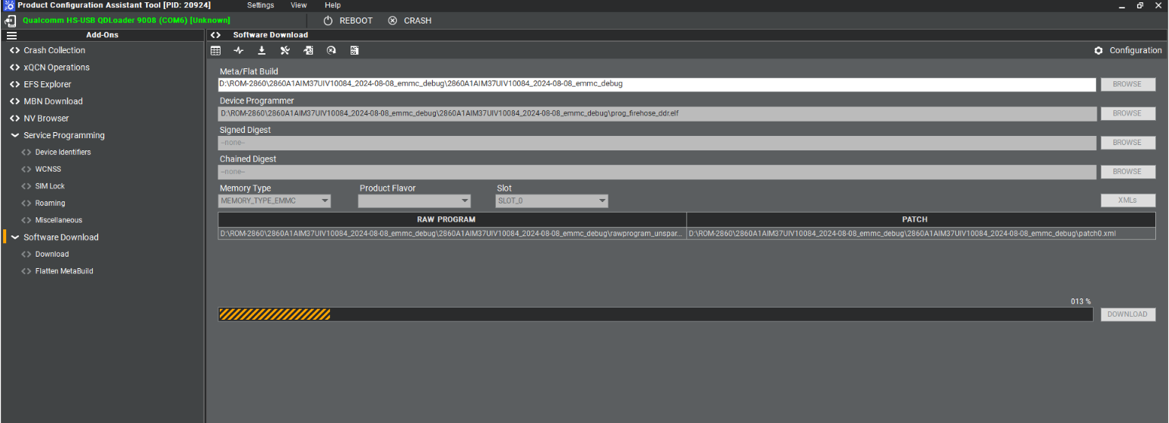
- EMMC Download completed
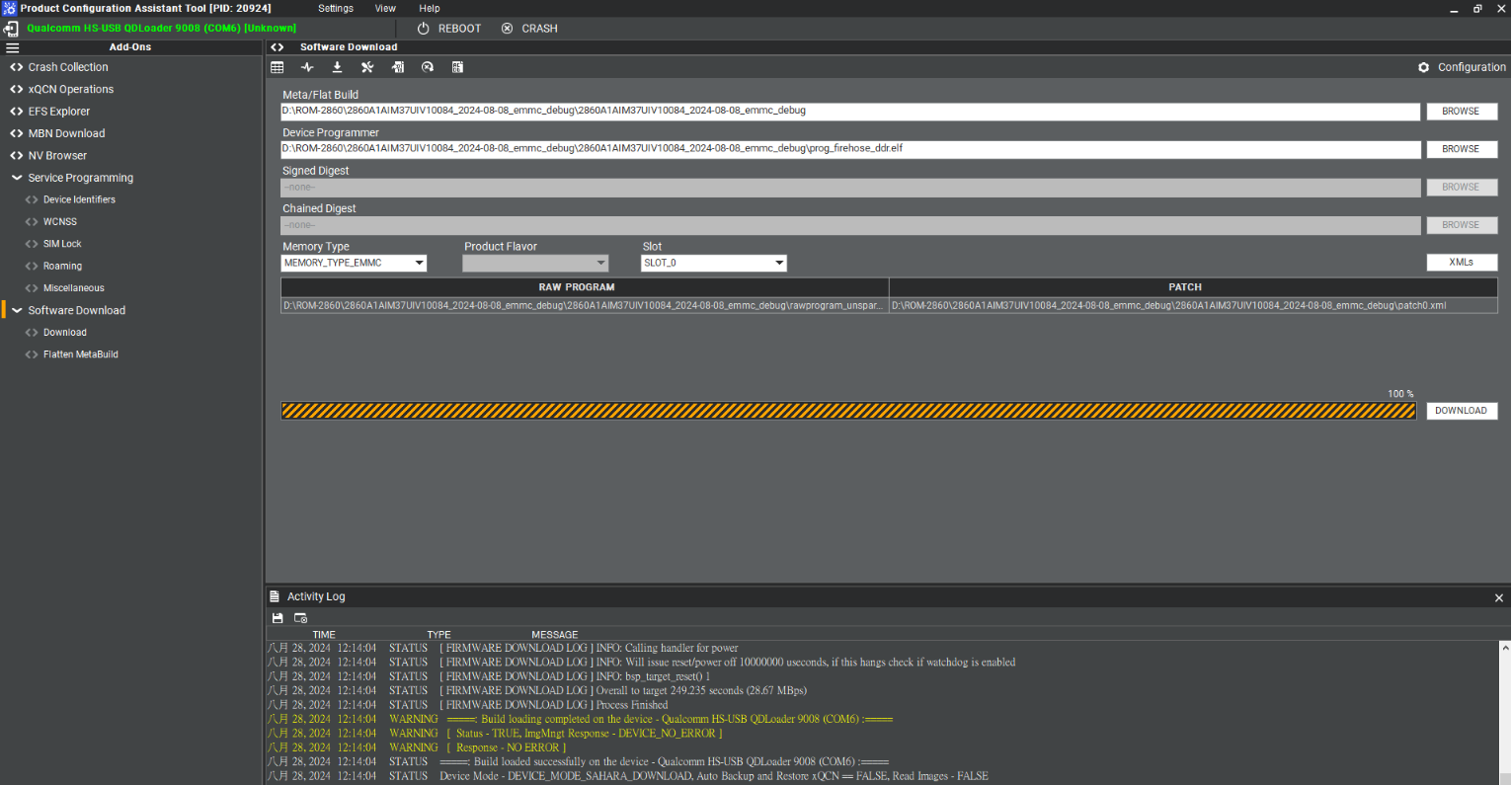

Qualcomm Download (QDL) Tool

One-time Prerequisite
To set the udev USB rule with the Qualcomm manufacturing vendor ID 05c6:
$ cd /etc/udev/rules.d
$ sudo vi 51-qcom-usb.rules
# add the following
SUBSYSTEMS=="usb", ATTRS{idVendor}=="05c6", ATTRS{idProduct}=="9008", MODE="0666", GROUP="plugdev"
$ sudo systemctl restart udev

Use the QDL to flash images (UFS only now)
- Ensure the QDL mode
$ lsusb
Bus 001 Device 028: ID 05c6:9008 Qualcomm, Inc. Gobi Wireless Modem (QDL mode)

- Ensure ModemManager is not running
It is identified as a Qualcomm modem for some Linux distributions when the device is connected in USB mode. Check the status of ModemManager:
$ sudo systemctl status ModemManager

If the ModemManager is enabling, please help to stop it by:
$ sudo systemctl stop ModemManager

- Go to the location of images in the workspace to flash the images:
$ cd build-qcom-robotics-ros2-humble/tmp-glibc/deploy/images/qcm6490/qcom-robotics-full-image
$ ./qdl prog_firehose_ddr.elf rawprogram*.xml patch*.xml
HELLO version: 0x2 compatible: 0x1 max_len: 1024 mode: 0
READ64 image: 13 offset: 0x0 length: 0x40
READ64 image: 13 offset: 0x40 length: 0x3f0
READ64 image: 13 offset: 0x1000 length: 0x1000
READ64 image: 13 offset: 0x2000 length: 0x260
READ64 image: 13 offset: 0x3000 length: 0x1000
READ64 image: 13 offset: 0x4000 length: 0x1000
.
.
.
Update Primary Header with CRC of Primary Header.
LOG: INFO: Calling handler for patch
Zero Out Header CRC in Backup Header.
LOG: INFO: Calling handler for patch
Update Backup Header with CRC of Backup Header.
LOG: INFO: Calling handler for patch
LOG: INFO: Calling handler for setbootablestoragedrive
LOG: INFO: Using scheme of value= 1
partition 1 is now bootable
LOG: INFO: Calling handler for power
LOG: INFO: Will issue reset/power off 100 useconds, if this hangs check if watchdog is enabled
LOG: INFO: bsp_target_reset() 1

If you see the "partition 1 is now bootable" in your terminal window, the flash is successful.
Note:
If you get the following issue, please help to download the qdl file (https://www.dropbox.com/scl/fi/nv65h778rwkhtul1gnwrr/qdl?rlkey=gzy83yt1x2qhhnqzra9kukhai&st=p4n42eax&dl=0) or to build the standalone QDL.
$ ./qdl prog_firehose_ddr.elf rawprogram*.xml patch*.xml
-bash: ./qdl: No such file or directory

How to build the standalone QDL?
$ sudo apt-get install libxml2-dev libudev-dev
$ git clone https://git.codelinaro.org/linaro/qcomlt/qdl.git
$ cd qdl
$ make

Chapter 6

Advantech Services
This chapter outlines Advantech's Design-In services, technical sup- port, and warranty policy for ROM- 2820.

RISC Design-In Services
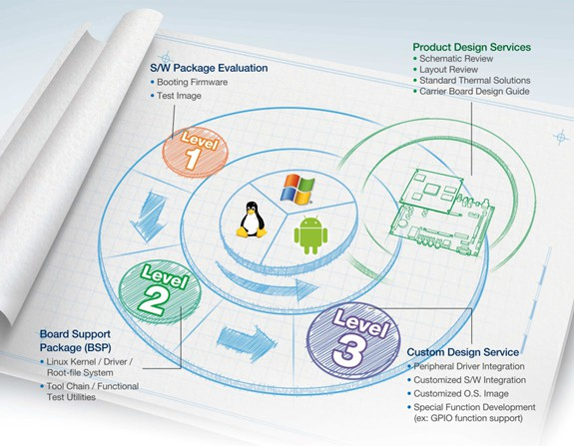
Advantech RISC Design-in Services help customers reduce the time and work involved with designing new carrier boards. We handle the complexities of technical research and greatly minimize the development risks associated with carrier boards.

Easy Development
Advantech has support firmware, root file-system, BSP, and other development tools for customers. These help customers develop their carrier board and differentiate their embedded products and applications.
          - Full range of RISC products
          - Comprehensive document support

Design Assistance Service
Advantech provides a checklist for engineers to check their schematics and review services based on customer carrier board schematics. These services prevent design errors before they occur. This saves time and reduces costs associated with developing carrier boards.
          - Schematic review
          - Placement and layout review
          - Debugging assistance services
          - General/Special reference design database

Chapter 6
Advantech Services

Thermal Solution Services
In order to provide quicker flexible solutions for customer's thermal designs, Advantech provides services including both modularized thermal solutions and customized thermal solutions
- Standard thermal solutions
- Customized thermal solutions

Embedded Software Services
This service provides support drivers, software integration and customized firmware, root file-system, and Linux image. Users can save time and focus on their core development.
- Embedded Linux/ Android OS
- Advantech boot loader customization

With the spread of industrial computing, a whole range of new applications has been developed, resulting in a fundamental change in the IPC industry. Due to diverse market demands and intense competition, cooperation on vertical integration is an effective way to create competitive advantages. As a result, ARM-based CPU mod- ules have grown in popularity. Concentrating all necessary components on CPU modules and placing other parts on the carrier board provides greater flexibility while retaining low power consumption credentials.
Advantech has identified the following common questions concerning the implementation of modular designs.

Data Acquisition
Despite obtaining sufficient information for making decisions concerning specialized vertical applications, some customers encounter difficulties dealing with platform design, and communicating with the CPU/chipset manufacturers. These challenges in carrier board design can negatively impact time-to-market at the expense of market opportunities.

Software Development and Modification
Compared to x86 architectures, RISC architectures use simpler instruction sets. Soft- ware support for x86 platforms cannot be used on RISC platforms. System integra- tors (SI) need to develop software for their system and integrate it with hardware themselves. Unlike x86 platforms, RISC platforms are not well supported by Board Support Packages (BSP) and drivers. While driver support is provided, system integration still requires a lot of effort. The BSP provided by CPU manufacturers is usually tailored for carrier board design, making system integration for software difficult.
Addressing this, Advantech introduced Streamlined Design-in Support Services for RISC-based Computer on Modules (COM). With a dedicated professional design-in services team, Advantech actively participates in carrier board design and problem solving. Advantech's services not only enable customers to effectively distribute their resources, but also reduce R&D costs and hardware investment.
By virtue of a cooperative relationship with leading original manufacturers of CPUs and chipsets - such as ARM, TI, and NXP - Advantech helps solve communication and technical support difficulties. This can reduce the uncertainties in product development. Advantech's professional software team focuses on providing complete Board Support Packages. They also help customers create a software development environment for their RISC platforms.

Advantech RISC design-in services helps customers reduce time to market by over- coming their problems through streamlined services.
Along with our multi-stage development process which includes: planning, design, integration, and validation, Advantech's RISC design-in service provides comprehensive support during the following different phases:
.

Planning Stage
Before deciding to adopt Advantech RISC COM, customers must go through a complete survey process, detailing product features, specifications, and compatibility testing with software. Advantech offers a RISC Customer Solution Board (CSB) as an evaluation tool for carrier boards which are simultaneously designed when devel- oping RISC COMs. In the planning stage, customers can use this evaluation board to assess RISC modules and test peripheral hardware. Advantech provides standard software Board Support Packages (BSP) for RISC COM, so that customers can define their product’s specifications while simultaneously verifying I/O and performance. Advantech also offers software evaluation and peripheral module recommendations (such as WiFi, 3G, BT). At this stage, Advantech seeks to resolve customer concerns. Product evaluation with a focus on performance and specification is vital during the planning period. Therefore, Advantech helps their customers conduct all the necessary tests for their RISC COM.

Design Stage
Advantech will supply a reference carrier board design guide when a product moves into the design stage. The carrier board design guide provides pin definitions for the COM connectors with limitations and recommendations for carrier board design. This design guide gives customers clear guidelines during their carrier board development. Advantech offers a complete pin-out check list for different form factors such as Q7, ULP and RTX2.0, enabling carrier board signals and layout design examination. Advantech's team helps customers review the placement/layout and schematics. This helps carrier board designs fulfill customers' requirements. Advantech’s RISC software team assists in establishing an environment for software development while evaluating the time and resources needed. Advantech can also cooperate with a third party to provide proficient consulting services in software development. With Advantech's professional support, the design process is eased and product quality is improved; thus meeting customer targets.

Integration Stage
This phase comprises HW/SW integration, application development, and peripheral module implementation. Due to the lack of knowledge and experience using plat- forms, customers need to spend a certain amount of time on analyzing integration problems. In addition, peripheral module implementation is relevant to driver designs on carrier boards. RISC platforms usually have less support for ready-made drivers on carrier boards, therefore users need to learn by trial and error to get the best solution with the least effort. Advantech’s team has years of experience in customer sup- port and HW/SW development. Advantech supports customers with professional advice and information shortening development time and enabling effective product integration.

Chapter 6
Advantech Services

Validation stage
After the completion of a customer's ES sample there is a series of verification steps. In addition to verifying a product's functionality, testing a product's efficiency is an important stage for RISC platforms. Through an efficient verification process, backed by Advantech's technical support, customers optimize their applications with ease. Advantech's team can provide professional consulting services regarding further testing and equipment usage. This helps customers find the right tools to efficiently identify and solve problems to enhance product quality and performance.

Contact Information
The contact information for Advantech customer service is below:

Region/Country Contact Information

United States of America | 1-888-576-9688
Brazil | 0800-770-5355
Mexico | 01-800-467-2415
Europe (Toll Free) | 00800-2426-8080
Singapore & SAP | 65-64421000
Malaysia | 1800-88-1809
Australia (Toll Free) | 1300-308-531
 | 800-810-0345
China (Toll Free) | 800-810-8389
 | Sales@advantech.com.cn
India (Toll Free) | 1-800-425-5071
Japan (Toll Free) | 0800-500-1055
Korea (Toll Free) | 080-363-9494  080-363-9495
Taiwan (Toll Free) | 0800-777-111
Russia (Toll Free) | 8-800-555-01-50
Alternatively, you can contact the Advantech service team via our website.
http://www.advantech.com.tw/contact/default.aspx?page=contact_form2&sub- ject=Technical+Support
Our technical support engineers will provide a quick response to your queries

Technical Support and Assistance

Warranty Policy
The warranty policy for Advantech products is provided below.

Warranty Period
Advantech branded off-the-shelf products and third-party off-the-shelf products used to assemble Advantech's Configure-to-Order products are entitled to a two-year global warranty. Products defect in design, materials, or workmanship are covered from the date of shipment.
All customized products will have a 15-month regional warranty by default. The actual product warranty terms and conditions may vary based on the sales contract.
All third-party products purchased separately will be covered by the original manufacturer's warranty and time period, and shall not exceed one year of coverage through Advantech.

Repairs under Warranty
It is possible to obtain a replacement product (cross-shipment) within the first 30 days after purchase. Contact your original Advantech supplier to arrange a replacement if the product was purchased directly from Advantech and was DOA (dead-on-arrival). The DOA cross-shipment excludes any shipping damage, customized and/or build- to-order products.
For products that are not DOA, the return fee to an authorized Advantech repair facility will be at the customer's expense. The shipping fee for reconstructed products from Advantech back to the customer will be at Advantech's expense.

Exclusions from Warranty
The product is excluded from warranty if:
        - The product has been found to be defective after expiry of the warranty period.
        - Warranty has been voided by removal or alternation of the product or part identification labels.
        - The product has been misused, abused, or subjected to unauthorized disassembly/modification; placed in an unsuitable physical or operating environment; improperly maintained by the customer; or failure from which Advantech is not responsible whether by accident or other cause. Such conditions will be deter- mined by Advantech at its sole discretion.
        - The product is damaged beyond repair due to a natural disaster, such as a lighting strike, flood, earthquake, etc.
        - The product is sent for updates, upgrades, or tests at the request of the customer who is without warranty.

Chapter 6
Advantech Services

Repair Process

Obtaining an RMA Number
All returns from customers must be authorized with an Advantech RMA (return merchandise authorization) number. Any returns of defective units or parts without valid RMA numbers will not be accepted; they will be returned to the customer at the customer's cost without prior notice.
An RMA number is only an authorization for returning a product; it is not an approval for repair or replacement. To request an RMA number, visit Advantech's RMA web- site: http://erma.advantech.com.tw and use an authorized user ID and password.
You must fill out basic product and customer information and describe the problems encountered in detail in "Problem Description". Vague entries such as "does not work" and "failure" are not acceptable.
If you are uncertain about the cause of the problem, please contact Advantech's application engineers. They may be able to find a solution that does not require sending the product in for repair.
The serial number of the entire product is required even if only a component is returned for repair. Otherwise, the case will be regarded as out-of-warranty.

Returning Products for Repair
Customers may be able to save time and meet end-user requirements by returning defective products to any authorized Advantech repair facility without an extra cross- region charge. Customers are required to contact their local repair center before global repair service will be offered.
We recommend sending cards without accessories (manuals, cables, etc.). Remove any unnecessary components from the card, such as the CPU, DRAM, and CF card. If you send all these parts back (because you believe they may be part of the problem), please clearly state that they are included. Otherwise, Advantech will not be responsible for any items not listed. Ensure that the Problem Description is enclosed.
European customers who are located outside the European community are requested to use UPS as the shipping company. We strongly recommend adding a packing list to all shipments. Please prepare a shipment invoice according to the following guidelines to minimize goods clearance time:
- Give a low value to the product on the invoice, or additional charges will be levied by customs that will be borne by the sender.
- Add information “Invoice for customs purposes only with no commercial value” to the shipment invoice.
- Show RMA numbers, product serial numbers, and warranty status on the shipment invoices.
- Add information about the goods Country of origin.
In addition, attach an invoice with the RMA number to the carton, write the RMA number on the outside of the carton, and attach the packing slip to save handling time. Please also address the parts directly to the Service Department and mark the pack- age "Attn. RMA Service Department".
All products must be returned in properly packed ESD material or anti-static bags. Advantech reserves the right to return unrepaired items at the customer's cost if inappropriately packed.
Door-to-Door transportation, such as speed post, is recommended for delivery. Otherwise, the sender should bear additional charges such as clearance fees if air cargo shipment methods are used.
Should DOA cases fail, Advantech will take full responsibility for the product and transportation charges. If the items are not DOA, but fail within warranty, the sender

will bear the freight charges. For out-of-warranty cases, customers must cover the cost and take care of both outward and inward transportation.

Service Charges
The product is excluded from warranty if:
        - The product is sent for repair after the warranty period is expired.
        - The product is tested or calibrated after the warranty period is expired, and a NPF (no problem found) result is obtained.
        - The product, though repaired within the warranty period, has been misused, abused, or subjected to unauthorized disassembly/modification; placed in an unsuitable environment; improperly maintained by the customer; or failure for which Advantech is not responsible whether by accident or other cause. Such conditions will be determined by Advantech at its sole discretion.
        - The product is damaged beyond repair due to a natural disaster, such as a lighting strike, flood, earthquake, etc.
        - The product is sent for updates, upgrades, or tests at the request of the customer who is without warranty.
If a product has been repaired by Advantech, and within three months after such a repair the product requires another repair for the same problem, Advantech will con- duct the repair free of charge. However, free repairs do not apply to products that have been misused, abused, or subjected to unauthorized disassembly/modification; placed in an unsuitable environment; improperly maintained by the customer; or failure for which Advantech is not responsible whether by accident or other cause. Please contact your nearest regional service center for detailed service quotations.
Before beginning out-of-warranty repairs, we will send you a pro forma invoice (P/I) with the repair charges stated. When you remit the funds, reference the P/I number listed under "Our Ref". Advantech reserves the right to deny repair services to customers who do not return the DOA unit or sign the P/I. Additionally, Advantech will scrap defective products without prior notice if customers do not return the signed P/I within three months.

Repair Report
Advantech returns each product with a repair report that shows the result of the repair. A repair analysis report can also be provided upon request. If the defect is not caused by Advantech's design or manufacturing, customers will be charged US$60 or US$120 for in-warranty or out-of-warranty repair analysis reports, respectively.

Custody of Products Submitted for Repair
Advantech will retain custody of a product submitted for repair for one month while waiting for the return of a signed P/I or payment (A/R). If the customer fails to respond within this period, Advantech will close the case automatically. Advantech will take reasonable measures to contact the customer during this one month period.

Shipping Back to Customer
The forwarding company for RMA returns from Advantech to customers is selected by Advantech. Other express services, such as UPS or FedEx, can be used upon request. However, the customer must bear the extra costs of alternative shipment methods. If you require any special arrangements, please specify this when shipping the product to us.

Chapter 6 Advantech Services
39
AOM-5721 User Manual

www.advantech.com
Please verify specifications before quoting. This guide is intended for reference purposes only.
All product specifications are subject to change without notice.
No part of this publication may be reproduced in any form or by any means, electronic, photocopying, recording, or otherwise, without prior written permis- sion from the publisher.
All brand and product names are trademarks or registered trademarks of their respective companies.
© Advantech Co., Ltd. 2024

